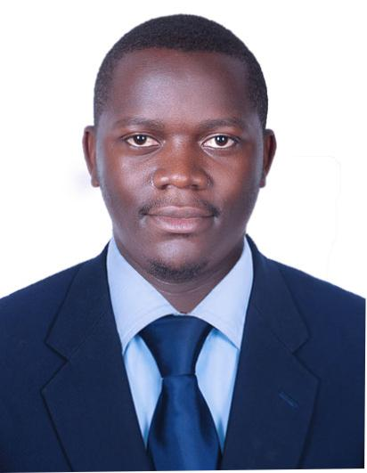
Lifeguard
Michael
Email: michael.380872@2freemail.com
Visa status: Visit- visa long stay
Precious job: Head Lifeguard; White sand Beach, kalangala, Uganda.
Objective
To ensure 100% safety and security of the guests by optimizing my experience and expertise in resort management, first aid, physical fitness and ability to make quick life-saving decisions.
Strengths
- 5+ years experience as a Lifeguard?

- 2+ years experience in management capacity
- Bachelor’s Degree, Business computing
- Certification, Red Cross Lifeguard Training
- Certification; Red cross First Aid and CPR Training
- Excellent swimmer and physically fit
- Excellent communication skills and outstanding team work spirit
- Pleasing personality and goal oriented
- Highly organized and punctual
Languages
- English – fluent
- Swahili – fluent
- Arabic – Basic
Work Experience
Head Lifeguard, 2017 to Present
White sand Beach kalangala – Uganda
Responsibilities:
- Monitoring and patrolling all areas of the beach
- Training and orienting new lifeguards
- Managing and evaluating team of lifeguards
- Conducting and leading physical fitness training for lifeguards
- Creating and updating safety guidelines and policies manual
- Addressing all issues, concerns and complaints from beach guests
- Reviewing and giving recommendations on improvements of beach facilities
- Rescuing guests at risk of drowning
- Leading search and rescue operations
- Implementing all beach rules and regulations
- Administering First Aid and CPR when needed
- Liaisoning with government health /safety and rescue agencies
- Ensuring cleanliness of the beach
- Cautioning guests of unsafe and hazardous activities
- Implementing courses of action in the event of emergencies
- Auditing and inspecting safety, working condition and maintenance of all equipment
- Preparing required reports and paperwork.
Team leader Lifeguard, 2014-2016
Jacaranda club mengo - Uganda
Responsibilities:
- Monitoring and patrolling all areas of the pool
- Evaluating team of lifeguards
- Conducting and leading physical fitness training for lifeguards
- Addressing all issues, concerns and complaints from pool guests
- Reviewing and giving recommendations on improvements of pool facilities
- Implementing all pool rules and regulations
- Implementing courses of action in the event of emergencies
Swimming Pool Lifeguard, 2013-2014
Makerere school pool Kampala – UGANDA
Responsibilities:
- Monitoring safety and well-being of all students in and around the swimming pool area
- Ensuring cleanliness, safety and upkeep of swimming pool
- Implementing all rules and guidelines of the pool.
- Cautioning students on unruly behaviour
- Assisting and rescues students in danger of drowning or when injured conducting First Aid and CPR
- Providing excellent student service relations
- Addressing all issues, complaints and concerns of students at the pool
- Conducting safety inspection of pool equipment and facilities
Education
Ndejje university Kampala - Uganda
Bachelor Degree, Business computing
2013-2016;
High School
Certified high school certificate
2010-2012
Courses
- Certification, Red Cross Lifeguard Training
- Certification, First Aid and CPR
- Certification, OSHA- Handling and Management of Dangerous Chemicals
- Microsoft office
Personal information
DOB 24/07/1993
Hobbies include swimming, music, reading

