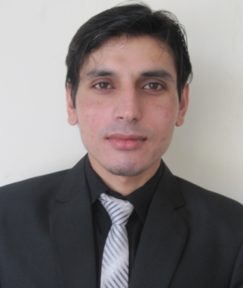
Neelab

Email: neelab.380883@2freemail.com

OBJECTIVE

Seeking a position at which I can utilize and enhance the knowledge, ability and skills. To create an exquisite employment experience by providing loyalty, safety, confidentiality and personalized services. Flexibility to handle situation and seeks skills with professionalism.

EDUCATION

- 2017
GoogleOnline Marketing Fundamental Training

- 2013-2017
Bachelor of Business and Administration (Honours)
Abdul Wali Khan University Mardan

- 2010-2012

HSSC (Pre-engineering)
Fazaia (PAF) Degree College, Risalpur Cantt, KPK
Major Subjects: Physics, Mathematics and Chemistry

- 2010

SSC (Science)
Working Folks Grammar School, Ziarat Kaka Sahib, Nowshera
Major Subjects: Science

EXPERIENCE

- August-September 2016
Had an internship at Pearl Continental HotelPeshawaras receptionist

- June 2013 to December 2015
Provided services as assistantat Taj Mahal Inn, Restaurant, Wedding Hall and Hotel
Helped in university social events as organizer

- 2010-2014
Helped in Nowshera flood recovery as volunteer

GOOD SKILLS IN

- Customer Services and Carrying
- Team Works
- Computer Maintenance
- Attending Guests and Clients
- Communications
- Creativity
- Analysis
- Management
- Marketing
- Human Resources
- Organizing

LANGUAGES

- Excellent written and oral proficiency in English (IELTS score 6) and Urdu
- Excellent oral proficiency in Pashto and Hindi

COMPUTER SKILLS

- MS-Word, MS-Power Point, Windows 10, 8,Seven, XP, Vista
- GOOGLE Products
- Apple ISO
- Adobe Photoshop
- Computer Hardware and Software
- Data entry
- Social Media
- Maintenance and Repairing
- Opera and Oracle System

INTERESTS

- Football
- Cooking
- Driving
- Movies
- Music
- Workout
- Hiking

REFERENCES

- Professional and personal references available upon request

