Randa
E: randa.380903@2freemail.com

Dear Madam/Sir,
I would like to express my interest on your vacancy for the post of Librarian.
I have been working in the field of library and organization and cataloguing of information for over 19 years. I have practiced this at different levels from management of libraries at universities, colleges and schools. Evidently, through my experience I established a library system from scratch using my enthusiasm, skills, patience and respect to colleagues and team work to achieve my goals.
During my tenure, I have been consistent in achieving my targets. I have also demonstrated my ability as a team member and formed great relationships with my co-workers as well as clients. Throughout my career I have assumed different library responsibilities with great success, not limited to being; Subject Specialist (management, rural extension and development, population education and women studies), Head Reference librarian, Head Readers’ services and Head Technical services.
Demonstrating my enthusiasm, I recently completed a critical and important in the field of library profession, which is MLIS qualification from the International Islamic University Malaysia. This qualification enabled to me to develop my skills in the field of information and library science including their digital application and latest developments. I am confident these key skills will enable me to add value in achieving my tasks within your organization.
Finally, I attached a detailed CV with this letter to give you insight on my skills and expertise and how they fit with goals and objectives of this vacancy and I would welcome the opportunity to discuss my candidacy in greater detail.

Thank you
Randa

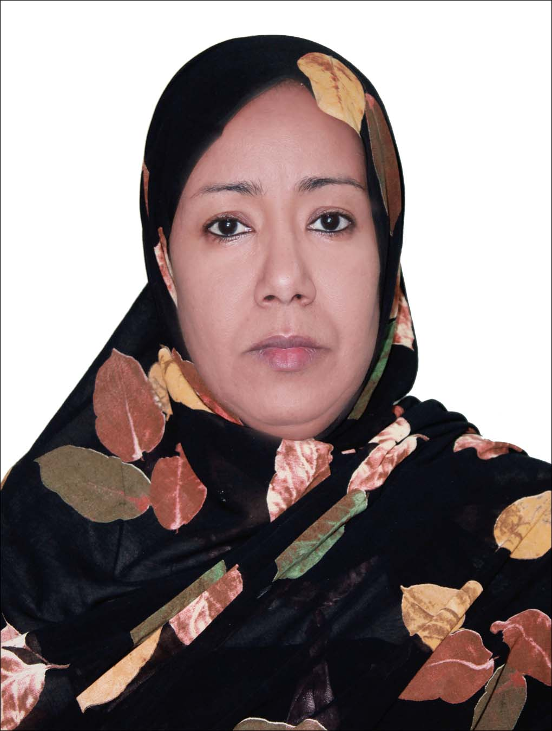onal with black/white attire.
Once you have you can place here. If not available then remove the box and apply without
Profile:
“An experienced librarian with MLIS qualification, well versed and competent in establishing library best practices and modern systems that can add value to education and research institutes to better serve and achieve their academic and education missions. With excellent communication and organizational skills to support achieving goals and accomplishing tasks.”

Education

- 2015 - 2017 Master in Library and Information Science (MLIS) with Distinction - International Islamic
University Malaysia

- 1992 - 1993 Post Graduate Diploma in library sciences with Distinction - University of Khartoum

- 1987 – 1990 B. Sc. In Organizational Management - Ahfad University For Women

Work Experience

- 2004 – 2015 Librarian - Western Private Model School
In this role I am leading the library users (students and teachers) in the school to allow and achieving school targets by serving number of students in the range KG1 to Grade 10 in various fields of Knowledge facilitating and here are some of the main tasks and activities:

- Building and using open access library systems to structure and operate the library.
- Designing and creating reading programs that has resulted in increasing library users by 60%.
- Creating and implementing all library strategies and procedures.
- Provide students and teachers with needed information services.
- Responsible for all library technical services; that is registering, classifying, cataloging, and coding.
- Refereeing patrons to most relevant information sources physical or online.
- Creative shelving and signage that help patron’s easy use of library premises.
- Creating and updating library records (OPAC, marc as well patrons' records).
- Insurance of high safety library measures including: temperature, light, fire, suitable shelves, etc.
- Follow up of all acquisition processes with consultation with different subjects reading lists recommended by relevant teachers.
- Enhancing students' reading habits through creative activities suitable for each age group: such as library captains, monthly library wall board, reading competitions, role plays, etc.

- 1994 – 1999 Head, Technical Services Librarian - Ahfad University For Women
In this function I was leading the technical service team to build a consistent library system in the area of bibliographic control using Anglo-American Cataloguing Rules and Dewey Decimal Classification System.

- Implementing library cataloging practices based on strategies and procedures stated by library
committee.
- Preparing collection for further technical process.
- Classification, cataloging, tagging, and Shelf check.
- Continuous OPAC checking.
- Compiling different subject bibliographies and subject guides.
- Checking bibliographic information in MARC 21.
- Reporting to University Library monthly progress of different library projects and staff
performance.
- Supervising all library system operations.

- 1993 – 1994 Head, Circulation Desk - Ahfad University For Women
In this function I was responsible for supervising all library lent materials (long and short). Also, I was also responsible for applying all borrowing policies and procedures.

- Checking in and out lent items and security tags.
- Communicating with various library patrons regarding any borrowing difficulty.
- Supervising re-shelving process.
- Control of short loan items (manuscripts and rare items).
- Administrative reports to University Librarian.

    - 1992 – 1993 Head, Reference Librarian - Ahfad University For Women
In this role I was instructing library patrons on how to use different resources and where to find their resources. Support direct information to their queries.
- Conducting information literacy classes for first year students.
- Training of library Patrons' and Assistants on using different information sources: encyclopedias,
dictionaries, almanacs, yearbooks, etc.
- Supporting citations and indexing of library contents.

    - 1990 – 1992 Subject Specialist, - Ahfad University For Women
In this function, I was responsible mainly to provide information to patrons in the fields mentioned below, and to be in continuous contact with the mentioned schools and departments concerned.

- Subject specialist for: management, rural development, women' studies, and population education.
- Providing different materials that help students in their assignments and projects.
- Contacting departments to prepare reading materials for their subjects prepare and finalize
acquisition lists.
- Directing book fairs and exhibitions introduced in different occasions such as United Nations
dedicated activities for relevant University themes.
- Contacting publishers and book stores regarding acquisition to achieve best offers and
Discounts.
- Shelving check.

Professional Development & Associations
- Skills in proprietary and open access ILS: Symphony, Koha, Senyan, and Greenstone. Classification: Library of Congress Classification System LLC, Dewey Decimal Classification System DDC, Anglo-American Cataloguing Rules AACR, MARC 21, and Cutter numbers.
- Subject analysis: LCSH and Lemur for indexing. Bibliographic databases retrieval.
- Library and Information Students Association, International Islamic University Malaysia, member, 2015.
- Certificate in Thesis Proposal Writing, International Islamic University Malaysia, Kuala Lumpur, 2016.
- Trained on How to Avoid Plagiarism. International Islamic University Malaysia, Kuala Lumpur, 2016.
- Certificate in Library Skills: Searching Journals Effectively. International Islamic University Malaysia, Kuala Lumpur, 2016.
- Certificate on How to Publish an Article. International Islamic University Malaysia, Kuala Lumpur, 2016.
- Professionalization of Teaching Skills. Ahfad University For Women, Omdurman, Sudan, 1994.
- Marketing of Information, British Council, Khartoum, Sudan, 1995.
- Certificate in UNESCO CDS/ISIS workshop, Arab Organization for Agriculture, Khartoum, Sudan, 1996.
- Member of the Association for Libraries and Information, 1996.
- Member of Arab Federation for Libraries and Information, Sudan Coordinator, 1993.

References Can be available on request

