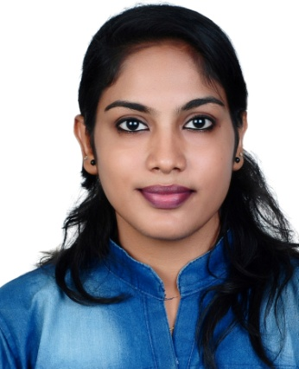  ANCY  Email id  Ancy.380926@2freemail.com  Personal Details  Name : Ancy  Date of Birth : 12th June 1992  Age : 25 yrs  Nationality : Indian  Marital Status : Married  Religion : Christian  Passport & Visa Details  Date of Expiry : 29/12/2026  Visa Status : Visiting Visa  Visa Expiry : 01/08/2018 | CURRICULUM VITAE  Career Objective  Looking for a challenging and demanding position in the industry that offers professional growth while being resourceful, innovative and flexible to work collectively in order to obtain organizational growth and objectives.  Academic Qualification  - M.E in Structural Engineering with 79% from Maria College of Engineering, , Marthandam in 2016  - B.E in Civil Engineering with 75% from Mar Ephraem College of Engineering, , Marthandam in 2014  - Higher secondary with 69% from New Higher Secondary School , Nellimoodu in 2010  - SSLC with 82% from St. Thereses Convent G H S S , Neyyattinkara in 2008  Software and Computer Knowledge  - Experience in Operating system (Windows7, Windows 8)  - Microsoft Word, Excel, PowerPoint  - Auto CADD  - STAAD Pro  - Microstation V8i  Work Experience  - Worked as Design and Estimation Engineer in Indotech Engineers from March 2016 – May 2018  - Have done estimation manually from drawings to obtain the quantities of various work to be done like earthwork excavation, concreting, steel reinforcement etc.  - One of the major projects was Construction of Aerial Passenger Ropeway in Jatayu Nature Park, at Jatayupara, Chadayamangalam(World's largest bird sculpture).
Job Profile
- Study the projects documents like drawings, specifications, and schedule, review tender documents and contract to be able to follow up on materials required.
- Visit site and record information about access and availability of services and materials.
- To review vendors and suppliers quotations to determine the best price and delivery date.
- Prepare comparative analyses documents related to specs, price, delivery conditions and mode of transportation.
- Engaged in the preparation & compilation of the necessary documents, information & technical inputs required for the completion of tender documentation.
- Analyse configurations of the basic components of a structure.
- Preparing reports,designs and drawings.
- Making calculations about loads and stresses.
- Review and verify design drawings and other technical documentation prepared by others to ensure correctness and accuracy in form, fit and function.
Strengths
- Believes in team work
- Goal oriented
- Resourceful
- Dedication towards duty
- Ability to work in any environment

Linguistic Proficiency
- To speak :English, Malayalam, Tamil
- To write :Malayalam, English, Hindi
- To read :English ,Malayalam, Hindi

Declaration
I hereby declare that above mentioned information is true to the best of my knowledge. With reference to the above information I, Ancy V S promise to devote myself in the institution with my hard work, if given an opportunity.

Place: Dubai Yours Faithfully,
Date:
Ancy

