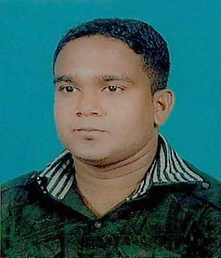
Curriculum Vita

Name : Garumuni
Email : garumuni.380934@2freemail.com

- Professional Profile:
- I am an enthusiastic and dedicated professional with extensive experience across all areas of can demonstrate a strong ability to manage projects from conception through to successful completion. A proactive individual with a logical approach to challenges, I perform effectively even within a highly pressurised working environment.

02. Working Experience :
- Three (3) years (2009/2010/2011) worked experience as the Branch Accountant at JMC Jayasekara Management Centre (Pvt) Ltd- Badulla in Sri Lanka.

- Three Years and Five Months Worked Experience as at the Night Auditor Cum Account’s Clerk at Camellia Resort & Spa (Pvt) Ltd in Sri Lanka. (Joining date 07.03.2013 Leaving Date 13.03.2015)

- I Have 1 Year and 06 Months Experience Using the Advance Accounting System. (TAURAS ADVANCE SOFTWARE).

- 2 Years & 2 Months Worked Experience as at the Accounts Supervisor at Amethyst Resort Passikudah - (Aitken Spence Hotel Managements (Pvt) Ltd in Sri Lanka. (Joining date 18.03.2015 Leaving Date 30.05.2017)

- I am Currently Working As An Income Auditor At The Amaara Forest Hotel (Pvt) Ltd in Sri Lanka From 2018.02.26.

KEY POINTS AS AN ACCOUNT’S SUPERVISOR

- All round Cashiering
- Creditor’s handling
- Debtors Handling
- Preparing JV & General Ledger
- Food Costing
- Income Auditing
- Preparing Day Sheet & Daily Report
- Preparing Service Charge & Salary

03. Computer Literacy:
- Institute : -The Super Infortec Computer Systems Ganewalpola – Kekirawa Sri lanka.

- Diploma : -Diploma in computer Application

- Medium : -English

04. Commercial Values :

- Interpersonal and Communication skills

English |  | Sinhala |  | Tamil
spoken | writing | spoken | writing | spoken | writing
Good | Good | Execellelent | Execellelent | Normal | Normal

- Conceptual and Decision making skills

- Leadership skills

05. Personal Details :

- Sex : - Male

- Date of Birth : - 1988.06.27

- Nationality : - Sri Lankan

- Marital Status : - Married

06. Educational Qualifications :

- G. C.E Advance Level- commerce stream- in 2007 August.

Subject Grade
Accounting S
Business Studies S
Economics S

- G. C.E (O/ L) - in 2004 December.

Subject Grade
Sinhala Lang. & Lit. A
Buddhism A
Health & Phy. A
Social Studies B
Commerce C
English C
Mathematics S
History S
Science & Tech. S
Art S

