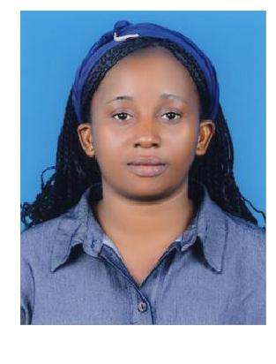
CURRICULUM VITAE

AREAS OF EXPERTISE

Hospitality Industry

Food and Beverages
Industry
Customer service

Maintenance
Complain Management
Customer satisfaction
Quality Assurance
Conflict Resolution

Data Protection Act
Compliance

PROFFESIONAL SKILLS

Excellent customer service skills.

Professional Development Superb Trainer.

Highly responsible and reliable.

Effective Organizational skills.

Excellent interpersonal skills Analytical and problem solving skills.

Well written communication skills.

Attention to detail high level of accuracy .

PATRICIA

PERSONAL DETAILS

Date of birth: | 22/08/1986
Gender: | Female
Nationality: | Cameroonian
Marital Status: | Single
Religion: | Christian
Address: | Dubai, UAE
Visa Status: | Tourist visa
E-mail: | Patricia.380939@2freemail.com

LANGUAGE: ENGLISH, FRENCH

POSITION APPLYING FOR: Waitress or any Suitable Position

EXPERIENCE: 3 years’ experience in Hospitality, Food and

Beverages Industry at VANILLYA RESTAURANT DOHA – QATAR

SUMMARY

Outgoing Waitress offering extensive knowledge of hospitality etiquette, and superior customer service. Organized, independent professional, splendid experience in the food service industry. Detail-orientated with strong time management skills and ability to learn new tasks quickly.

EDUCATION BACKGROUND

• HIGH SCHOOL DIPLOMA – CAMEROON 2006 • DIPLOMA IN HOTEL MANAGEMENT, CERFOREST
HOBBIES AND | HOTELLERIE – CAMEROON 2010
INTRESTS | PROFFESSIONAL EXPERIENCE
Serving | ➢ VANILLYA RESTAURANT DOHA – QATAR
Cooking
 |  |  | 2014 – 2016
Reading
Running
Socializing | Position: WAITRESS
Traveling
 | Responsibilities:
 | • Greet and welcome customers, Present menus, and answer questions
 | about menus items, and making recommendations upon request.
 | • Informed customers of daily specials promotions in the restaurant.

- Take orders from guests for food or beverages and ensure all guest meet the necessary age restriction for consumption of drinks.

  - Serving customers with their correct orders and make sure they approve and are happy.

  - Effectively communicated with kitchen staff regarding customer allergies, dietary needs, and other special requests.

    - Implementing an online marketing plan to promote restaurant’s dishes to a wider range of people.

    - Accurately recorded orders and partnered with team members to serve food and beverages that exceeded guests’ expectations.

    - Responsible to prepare receipts and collect payments from the customers

    - Inquired about guest satisfaction, anticipated additional
- FINESS HOTEL YAOUNDE - CAMEROON

2010 - 2013
Position: Waitress

Responsibilities:

- Take orders and serve dishes at tables according to order.

- Recommend wines and other drinks to customers.

- Prepares bills and collect payments from the customers.

- Actively take part in the cleaning of the restaurant

- Attended monthly staff meetings and training sessions.

- Also assisted in sales.

LANGUAGES

ENGLISH: EXCELLENT
FRENCH: EXCELLENT

INETRESTS

- Achieving set up goals

- Building good relationship and learning from the new environment

- Learning new developmental skills

- Learning more about the new environment and the new people

- Working in a team

References upon request…

DECLARATION: I declare that all the information given above is true to the best of my knowledge.

