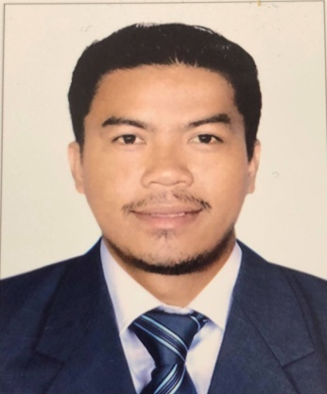

JUNREY
Junrey.380957@2freemail.com

Summary

Ambitious HVAC Technician with strong background in plumbing, refrigeration machinery operations and HVAC repair and maintenance. Excellent understanding of HVAC controls.
Technical college graduate with 9 years in the AC service and repair industry hard working and Flexible.
Installation Technician successful at developing unique troubleshooting techniques and providing quality sound installation services to customers.
Highlights
- Certified HVAC Technician
- Preventative maintenance
- Leak checks
- Operation and maintenance expert
- In-depth knowledge of refrigeration systems
- Pumps, fans and cooling towers
- Ventilation and air conditioning
- Installation expert
- Self-motivated
Experience
HVAC TECHNICIAN
SMART CO ELECRTO MECHANICAL CONTRACTING SERVICES
SAUDI ARABIA RIYADH
MARCH 2010 UP TO MAY 5 2018

- Troubleshot and repaired HVAC and refrigeration equipment.
- Disassembled units, repaired broken components and restored them to operating condition.
- Overhauled and repaired reciprocating and centrifugal compressors.
- Maintained and serviced HVAC systems and refrigeration equipment.
- Installed and maintained ammonia-based refrigeration equipment.Collaborated with plant engineer to resolve 10 HVAC and refrigeration issues per week.
- Assessed the accuracy of HVAC and refrigeration PM procedures and gave feedback to management.Examined heating and refrigeration systems, air-conditioning and air compressors for signs of defects or malfunction.
- Soldered and brazed damaged equipment.
- Installed air conditioning and refrigeration equipment and tested them for proper operation.

HVAC TECHNICIAN
HOLIDAY INN HOTEL (UNDER SMART CO COMPANY)
SAUDI ARABIA RIYADH
JULY 2012-AUGUST 2013

(Please be inform that my Company SMART CO ELECRTO MECHANICAL CONTRACTING SERVICES send me to HOLIDAY INN hotel to work as HVAC TECHNICIAN FOR 1 YEAR)

- Repaired and replaced condensers, compressors, pumps and valves.
- Completed an average of 10 preventative maintenance jobs, site surveys, replacements and modifications each week.
- Completed preventative maintenance on refrigerators and freezers.
- Examined and repaired variable frequency drives.
- Responded to complaints about temperature problems in a timely manner.
- Recycled and charged refrigerants.
- Complied with engineering standards and practices at all times, including cGMPs.

AIRCON MAINTENANCE
PACIFIC REGENCY HOTEL
MALAYSIA KUALA LUMPUR
FEB 2007-MAY 2009

- Retained careful and thorough maintenance and repair records.
- Analyzed, modified and repaired digital control systems.
- Scan-tested HEPA filters at specified flow rates.
- Documented and reported each installation in company log book.
- Inspected installation sites to determine material requirements.
- Disassembled broken and defective equipment to facilitate repair.
- Reassembled equipment after completed repairs.
- Wired outlets, connected circuits and breakers and replaced fuses and fuse boxes.
- Used hand tools to replace defective equipment parts.

AIRCON MAINTENANCE
HILTON HOTEL
PHILIPPINES CEBU
MARCH 2006-APRIL 2007

- Assisted journeyman electrician with installation, repairs and maintenance of electrical systems.
- Maintained up-to-date and accurate repair logs.
- Responded to complaints about temperature problems in a timely manner.
- Examined heating and refrigeration systems, air-conditioning and air compressors for signs of defects or malfunction.
- Retained careful and thorough maintenance and repair records.
- Supervised equipment returns, including obtaining all relevant data.Inspected installation sites to determine material requirements.

Education

- CEBU TECHNOLOGICAL UNIVERSITY (CTU)
BACHELOR OF SCIENCE AND INDUSTRIAL TECHNOLOGY
MAJOR IN REFREGERATION AND AIRCONDITIONING
DANAO CITY CAMPUS CEBU
2001 ~ 2006

• GARING NATIONAL HIGH SCHOOL
CONSOLASCION CEBU
1997~2001

• SAN ROUE ELEMENTARY SCHOOL
LILOAN CEBU
1991-1997

REFERENCES
UPON YOUR REQUEST

