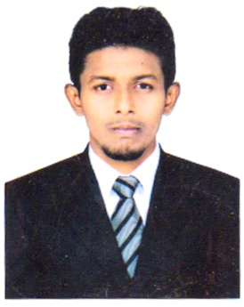

NITHIYAS

EMAIL: nithyas.380961@2freemail.com

CAREER OBJECTIVE:
To be part of an organization, which provides me ample opportunities to exercise my skills and establish myself in an accounts receivable section with a passion to succeed.

PERSONAL PROFILE:
Date of Birth : 16/05/1994
Gender : Male

Religion : Islam

Nationality : India

Languages known : English, Tamil, Hindi.

EXPERIENCE DETAILS:
Organization : Cams Cargo Accounting Management Services Pvt, Ltd.,
Designation : Accounts Executive – QN Projects
During Period : 2014 – 2015

Organization : Fortune Grand Hotel, Dubai.
Designation : Accounts Receivable
During Period : 2016-Current

ROLES AND RESPONSIBILITIES:
- Provide customer services from shipment tracking and inquiry.
- Manifesting.
- Ensure the safety and security of the shipments arrival in its correct destination.
- Filing and updating office documents.
- Briefing the personnel in operation to avoid conflicts.
- Dedicated to completing tasks on or before deadlines.
- Responsible for organizing and maintaining all accounts receivables active files
- Generate weekly aging reports.
- Compile data and prepare monthly reports and statements.
- Monitored credit limits.
- Followed up and allocated payments.
- Preparing General Ledger reclassification entries.
- Invoicing of individual FIT’s bookings, tour companies and conventions.
- Posting of A/R payments and advance deposits.
- Researching overdue accounts to ensure follow up on collection.
- Preparation of daily MIS report.
PROFESSIONAL QUALIFICATION:
- B.COM (GENERAL) – with an aggregate of 60% in Jamal Mohamed College under the Bharathidasan University Trichy during (2011- 2014).
- Diploma in Air cargo & Sea cargo & logistics Management from Trade Wings Institute of Management Chennai (2015-2016).

TECHNICAL SKILLS:

- Operating Systems WINDOWS
- Software MS-EXCEL, TALLY ERP 9, WIN HMS,
PEACH TREE.

FIELD OF INTEREST:

- Cargo Sector (air & sea cargo sector)
- Accounts & Administration.

