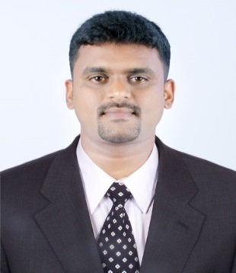
Vyshal On Visit Visa

Date of Birth: 13/11/1988
vyshal.380979@2freemail.com
CAREER OBJECTIVE
To be a part of an organization that offers challenging career and projects, which will enhance my learning, knowledge and skills to enable me to contribute maximum to the organization and develop and grow along with the organization
PROFESSIONAL EXPERIENCE
- Worked as HR ADMINISTRATOR in IL&FS, from June 2016 to March 2018.

DUTIES AND RESPONSIBILITIES
    - HR/RECRUITER
    - TERRITORY COORDINATOR
    - STORE KEEPER
    - TRAINER OF TRAINERS
    - ADMINISTRATOR
    - Conduct meeting whenever necessary
    - Arrange Monthly Meeting
    - Prepare new ideas and planning’s for employees
    - To check the attendance and salary of employees
    - Reports to the Project Manager

- Worked as HR TRAINEE in HOTEL VARSHA INTERNATIONAL from January 2015 to August 2015.
- Attend meetings behalf of the HR Manager
- Assists with the organization of the staff social events
- Manage HR administration such as conytacts, letters and personnel files
- Maintenance of HR email account and ensures prompt reply
- Orientation for new hires

- Worked as Admin/Customer Relation Executive in a Two-wheeler showroom fromJune 2010 to August 2012.
- Explains about the product
- Follow up with the Customers
- Worked as freelance Insurance advisor in BIRLA SUNLIFE Insurance Company &MAX BUPA Health Insurance Company.
ACADEMIC PROFILE
- Master of Business Administration (MBA) from Pondicherry University
- Bachelor of Business Administration (BBA) from Calicut University

ACADEMIC SPECIALIZATIONS
- HUMAN RESOURCE MANAGEMENT & MARKETING MANAGEMENT

ACADEMIC PROJECTS
- COMPLETED TWO MONTHS PROJECT WORK ON “A STUDY OF EMPLOYEE PERSONALITY” WITH REFERENCE TO GEMINI PLASTIC, THALASSERY, KERALA

- COMPLETED TWO MONTHS PROJECT WORK ON “INVENTORY MANAGEMENT” AT UCAL FUEL SYSTEMS LTD., PUDUCHERRY, TAMILNADU

PROFESSIONNAL SKILLS
Administration, Coordination, Employee-Relation, Training & Development.
PERSONAL SKILLS
- Willingness to Learn and work in any Shifts.
- Positive Attitude, Confident, Flexible, Friendly and Keen to help others.
- Can easily adapt to new people, new place and new situation.
- Hardworking and very eager to finish the given task within short span of time.
COMPUTER SKILLS
Word/Excel/PowerPoint
PERSONAL TRIVIA
- Gender : Male
- Marital Status : Single
- Linguistic Skills : Malayalam, English, Hindi & Tamil
- Hobbies : Travelling, Swimming
REFERENCE: –can provide on demand.
DECLARATION
I, Vyshal hereby declare that all the above-furnished details are correct to the best of my knowledge and belief.
VYSHAL

