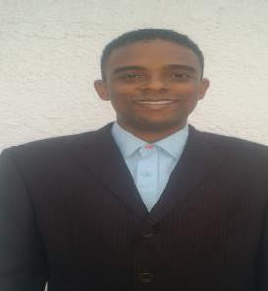
KASSIM

Kaseem.380999@2freemail.com

PERSONAL INFORMATION

Nationality: Kenyan

Marital Status: Single

Religion: Muslim

Languages: English, Swahili, Hindi/Urdu, Arabic

Date of Birth: 18th July 1991

SUMMARY PROFILE AND CAREER OBJECTIVE

I am a young man who enjoys working with others as a team. I pay attention to detail and quick to learn new concepts and to adopt to my work environment. I am highly motivated and can work with minimal supervision. I am a person who enjoys challenges and gain a great self-satisfaction when I complete the goals and tasks assigned to me in a timely fashion. I am currently looking for a full-time position in a creative and challenging environment in order to build on my marketing skills and to gain more exposure and experience in the field

EXPERIENCE

• National Bank of Kenya July 2016 - Nov 2016

National Amanah (Islamic Banking) as a Direct Sales Representative where I was In charge of developing new business prospects in specific geographic areas through cold calls while interacting with existing customers to increase sales of the bank's products and services.

• Radio Salaam Feb 2017 - Dec 2017

Marketing Department where I oversaw Outsourcing for clients to advertise with our media channel, writing of marketing proposals, directly contacted clients and made payment follow ups, advised

clients in regard to our brands and creative department where I prepared advertisement scripts for voicing.

• Makadara Youth Group Jan 2018 - Current

One of the founders and active members of M.Y.G where our functions were creating drug awareness among the youth and its adverse effect in life and also raising funds for the needy and drug addicts

1 | 2

EDUCATION

- 2011–2016: Bachelors of Science in International Business Administration-Marketing Concentration

UNITED STATES INTERNATIONAL UNIVERSITY(USIU), Nairobi, Kenya.

- 2006-2011: International General Certificate of Secondary Education (IGCSE) PRISTINE PRIVATE SCHOOL. Dubai, U.A.E

- 2003-2006: Kenyan Certificate of Primary Education (KCPE) QUBAA ACADEMY PRIMARY SCHOOL. Mombasa, Kenya.

TECHNICAL SKILLS AND KEY COMPETENCIES

- Good persuasion and lobbying skills

- Excellent interpersonal and communication skills

• Good ability to identify and interpret business needs in a cross-cultural environment Good analytical skills and having ability to work well under pressure.

- Well Equipped in Microsoft Office (Word/Excel/PowerPoint/Outlook)

HOBBIES

- Travelling

- Socializing

- Swimming

- Football

- Community Service

2 | 2

