P A R E S H
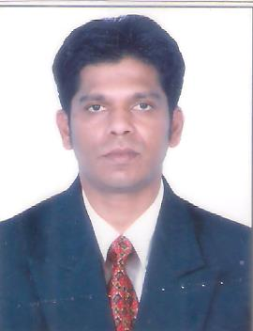

Email: paresh.381010@2freemail.com

Possessing enthusiasm, drive and a positive attitude required to be successful in a hospitality and customer service environment.

P E R S O N A L I N F O R M A T I O N

Born December 27th 1979 Citizenship: India
Marital status: married, kid

W O R K H I S T O R Y

11.2015 – Present Varca Le Palms Beach Resort – Goa
Floor Supervisor

  - Staffing and making duty rosters.
  - Ansure that floor rooms and offices are setup in accordance
Of the company standards.
  - Responsible of taking all precautions and fulfill all requirements of stationary regulations relating to the area of work assigned.

- 2006 – 09. 2015 NORWEGIAN CRUISE LINE – MIAMI, USA

Galley Utility and then promote Housekeeping Dept
  - Helping in kitchen maintainence.
  - Follow the USPH norms
  - Helping in Housekeeping.
  - Maintaining guest rooms

- 2004 – 12.2006 EMIRATES PALACE- ABU DHABI, UAE

Housekeeping Attendant

  - Responsible for maintaing rooms.
  - Maintaining offices cleanliness.
  - Ansure that the rooms and offices are setup in accordence of the company standerds.

- 2000 – 02. 2002 HERITAGE VILLAGE CLUB, GOA

Resort Attendant

  - Responsible to maintain rooms and also public area

E D U C A T I O N

04. 1996 – 04.1997 SECONDERY SCHOOL EXMINATION (10TH)

Q U A L I F I C A T I O N S

ITI in Electronics ITI in Typing
Successfully completed STCW 95/2010 Course

