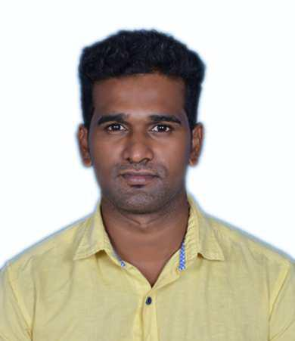
RESUME

MUTHU, Dip (Mech.)
E-mail: muthu.381039@2freemail.com

CAREER OBJECTIVE:

To become a successful professional and work in a competitive environment, which will help to expose my creative skills towards the development of the organization.

EDUCATIONAL QUALIFICATION:

S.l | Course | Name of the Institution | Year of Passing | Percentage of
No |  |  |  | marks
1. | Diploma. | Sri Krishna Polytechnic College | 2013 | 69.0 %
 | (Mechanical Engg.) | Batlagundu.

COMPUTER KNOWLEDGE:

Auto CAD-2014 CNC programming
Micro Soft Office-2007

PROFESSIONAL EXPERIENCE:

1. | ORGANIZATION | : LAKSHMI MACHINE WORKS LTD, UNIT-1, COIMBATORE. INDIA
 | Duration | : April 2014 – May 2015
 | Position | : CNC OPERATOR (TRAINEE)
2. | ORGANIZATION | : SAM TURBO INDUSTRY PVT LTD, COIMBATORE. INDIA
 | Duration | : March April 2017 – May 2018
 | Position | : CNC OPERATOR

Jobs description:

Physical and Instrumentation verification as part of QA / QC procedures for final products on regular interval to ensure that products are as per drawings.

QC pass and report preparation for the compliance products prior to packing.

Reporting of Non-Compliance products to the concern team for rectification works. Shift handing over procedures to the preceding shift.

Instruments Handled:

Vernier caliper, Screw gauge, Height gauge, Plug gauge, Depth Vernier, Bore dial, Concentric dial.

INPLANT TRAINING AND PROJECT DETAILS:

- PROJECT TITLE: Design and development of automatic side stand with break locking system for Two wheelers.

- IN PLANT TRAINING: Railway carriage and wagon department.

PERSONAL DETAILS:
D. O. B |  | : 10-05-1994
Nationality |  | : Indian
Languages |  | : Tamil, English
Marital Status |  | : Unmarried

