CURRICULUM VITAE
JAYAKRISHNAN  E-mail: jayakrishnan.381040@2freemail.com |  | 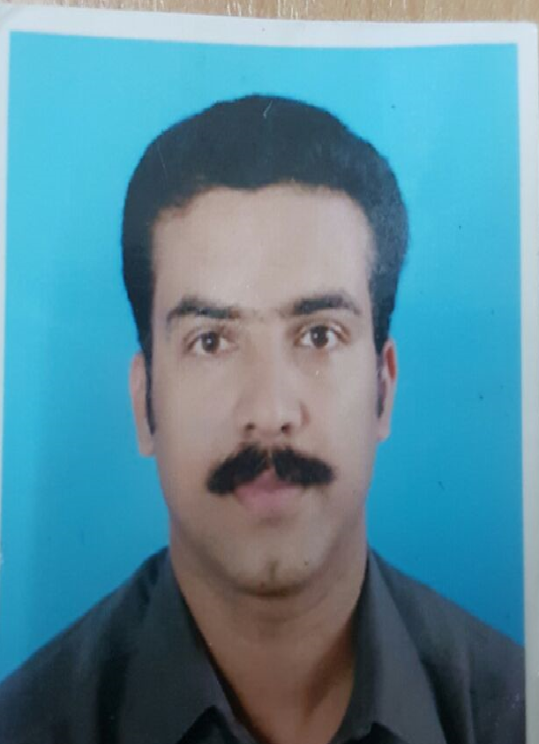
Areas of Interest :
Office Manager
Administrator
Personal /Executive Assistant

Objective :
To obtain a full time, permanent and challenging position which offers opportunities
for career growth.

Summary:
More than 20 years sound experience as Office Administrator/Executive Secretary/
Personal Assistant to top level management in medium and large sized companies in
India and Oman.
Total Work Experience in Oman : 20 years experience

Since June 2006 To till date

Company | Since June 2006 - March 2018, worked with M/s. Al-Hashar & Co. as “Personal Assistant’ to CEO –Sultanate of Oman.
Responsibilities | - Acts as a proxy representative of the CEO within the company for the purpose of non crucial meetings and communications.
Responsibilities | - Operates in direct support of the CEO in the operation of his duties
Responsibilities | - Managing the CEO’s time; scheduling the working day, carrying out diary management and co-ordination of all demands to achieve the maximum effectiveness of the CEO’s day arranging international conference
Responsibilities | - Directs the office assistants to screen incoming calls, check emails, review documentation, send mail, do basic research, scheduling reservation, booking travel and meetings.

Page 1 of 4

 | - Carries out a variety of routine duties to facilitate the smooth running of the CEO’s Office such as preparing confidential letters and memoranda, arranging attendance of CEO at business events and corporate functions, answering routine calls from senior staff or principals and attending to the board members routine requites.
 | - Performs a variety of administrative or executive support tasks that are highly confidential and sensitive.
 | - Undertakes a variety of other tasks and duties as directed by the CEO.
Since Nov. 1997 to May 2006

Company | M/s. Bahwan Engineering Co. LLC.  (BEC is one of the leading contracting companies in the Sultanate of Oman, integrating, diverse engineering construction activities in the field of Civil, Mechanical, Electrical, Instrumentation, Power and Oilfield operations. Construction activities including Substations for power generation, overhead lines Hospitals etc. Also specializing in installation & maintenance of Elevators and Escalators, maintenance of Hospitals, Airport, Trading in Electrical, Air-conditioning products etc.)
Positions (Various) | Executive Secretary, Project Coordinator, Office Administrator, HR Executive etc.
Responsibilities | - Co-ordination with various Department Heads and Executives.
Responsibilities | - Preparation of confidential documents.
Responsibilities | - Organize office operation and procedures
Responsibilities | - Deal with suppliers & overseas visitors and communicate with them.
Responsibilities | - Preparation of Tenders and routine correspondence.
Responsibilities | - Conduct meetings and prepare minutes of meeting.
Responsibilities | - Review and approve supply requisitions
Responsibilities | - Design filing systems and ensure filing systems are maintained and up to date.
Responsibilities | - Ensure protection and security of files and records
Responsibilities | - Ensure effective transfer of files and records.
Responsibilities | - Scan the calls & papers (incoming and outgoing), ticket booking, travel and hotel arrangements in addition to the general secretarial works.

Page 2 of 4

Total Work Experience in India – More than 5 years experience

Company | - Since March 1995 to Oct. 1997: Worked as Executive Secretary to the Managing Director with M/s. Mini Electronic Ind. Pvt. Ltd. , Mumbai.
Company | - Since Jan. 1994 to Feb.1995: Worked as Secretary Cum Accounts Assistant (For Marketing Division) with M/s. Solar Electrical Stampings, Mumbai.
Company | - Since Sept. 1993 to Jan.1994: Worked as Accounts Assistant for M/s. Skansen Engineering Co. Ltd. Mumbai.
Company | - Since March 1990 to Aug. 1992: Worked as Admin. Executive for M/s. Top Tec. Computer Academy (Kannur Dt.) Kerala State.
Responsibilities | - Keep track of employee movements in various sites.
Responsibilities | - Preparation of confidential documents and self-correspondence.
Responsibilities | - Preparation of bank reconciliation statement.
Responsibilities | - Preparation of salary, leave settlements etc. in the payroll section for staff and workers.
Responsibilities | - Sub-contract accounting & payments to subcontractors, accounting and payment to casual labour contractors.
Responsibilities | - Review and follow up of receivables and payables.
Responsibilities | - Maintaining manual record of fixed assets.
Responsibilities | - Preparation of cash vouchers and purchase vouchers.
Responsibilities | - Reconciliation and settlement of monthly bills of Tele. and insurance etc.
Responsibilities | - Billing of maintenance jobs for various sites.
Responsibilities | - Preparation of local/international purchase orders and follow up.
Responsibilities | - Scan the calls & papers, ticket booking, travel and hotel arrangements etc.

Page 3 of 4

Qualifications
Academic | Bachelor of Commerce (B.Com) from Calicut University, Kerala State
Technical | Computer Application Course from Govt. Poly Technic – Kerala State, Govt. of India.  (Excellent in Office Automation Packages including M.S. Office [Word, Excel, PowerPoint & Access], Internet applications, FoxBASE, FoxPro etc.)
Technical | Typewriting (English) Higher from  Kerala Govt. Technical Education  Board. India
General | Social Forestry Course from S.F.T.I (Social Forestry Training Institute – Trivandrum, Kerala) India.
Personal Details
Name | Jayakrishnan
Date of Birth | 31-05-1971
Nationality | Indian
Languages Known | English, Hindi and Malayalam- (Read/Write/Speak)  Tamil & Arabic (Speak).
Passport Details
Place of Issue | Kozhikode
Driving License - Oman & India
Significant Achievement
Training | Training Omanis in various area (Administration).

Page 4 of 4

