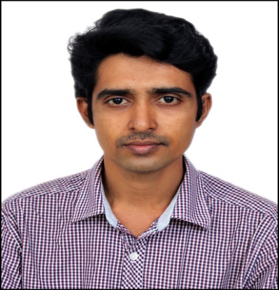
Rajasankar

Administration

Rajasankar.381063@2freemail.com
WORK EXPERIENCE

Administration/Operations Manager
CANGO NETWORKS PVT LTD April 2013 – March 2018
Duties/Tasks/Responsibilities
- Reports to and works directly with the Director of Company.
- Scheduling and tracking of all appointments, meetings & welcoming guests.
- Event Management on various activities.
- Set up and coordinate meetings and conferences.
- Monitoring and updating on team / dept. performance.
- Solving issues, making appropriate decisions and cost cutting.
- Handling various official and personal engagements in confidence.
- Diary Management.
- Coordination on financial processes with documentation.
- Handling independent correspondence, filing, petty cash and payments / reimbursements.
- Handling Travel / Accommodation (Domestic and international) itineraries.
- Liaising and coordinate the flow of information both with internal and external contacts.
- Procurement / negotiation / inventory processes & liaising with clients / vendors.
- Establishes and maintains electronic records management system for all incoming and outgoing correspondence.
- Controls, orders, and keeps an Inventory of Office Supplies.
- The Invitation Letter, VISA Processing, Travel Insurance, Forex Purchasing and Card Top-up and Deputation Documents for employee onsite travel Planning.
- Perform detailed analysis of accounts, prepare month-end reports, and presented findings to top level management.
- Prepare and file the necessary annual tax forms according to company and state policies.
- Conduct a review of the monthly Business Activity Statements and balance sheet reconciliations are discuss with Auditor.

Testing Engineer
ASCOTT ELECTRICALS PVT LTD - Chennai, India.
January 2012 – March 2013

Job Responsibilities:
•Testing all type of Transformers (Instrument Transformer, Distribution Transformer and Power Transformer).
•Preparation of Test report for Transformers.
•Attending technical discussion with client and consultant for modification according to customer and system requirement.
•Site work related to project division.

Admin / IT Admin
WAFES TECHNOLOGIES PVT LTD - Chennai, India.
April 2006 – December 2011

Job Responsibilities:
- Develop and maintain a filing system.
- Order office supplies.
- Book travel arrangements.
- Submit and reconcile expense reports.
- Provide general support to visitors.
- Planning meetings and taking detailed minutes.
- Handle administrative requests and queries from senior managers.
- Write and distribute email, correspondence memos, letters, faxes and forms.
- Update and maintain office policies and procedures.
Requirements:
- Proven administrative or assistant experience.
- Knowledge of office management systems and procedures.
- Excellent time management skills and ability to multi-task and priorities work.
- Attention to detail and problem solving skills.
- Excellent written and verbal communication skills.
- Strong organizational and planning skills.
- Proficiency in MS Office.

EDUCATION

BACHELOR OF ENGINEERING
Form S.R.M.Engineering College, University of Madras.
ADDITIONAL INFORMATION
COMPUTER SKILLS
- Operating system: windows XP & windows 7.
- Applications: MS office 2003, 2007& other windows utilities.
- Accounting all financial transactions in computerized environment using Tally ERP.9
Skills & Abilities
- Excellent leadership and time management skills.
- Amazing analytical ability by thinking through tasks assigned which leads to logical conclusions.
- Great communication and interpersonal skills.
- Flexible and able to adapt to change.
- Excellent Computer Skills and is Expert in using Microsoft Office (Word, Excel, Outlook, PowerPoint).
- Excellent Organizational skills, effective multi-tasking skills and able to meet tight deadlines.
- Excellent in maintaining extreme confidentiality under any situation and/ or development projects.
- Outstanding customer service attitude.
- Fluent in English.
- Able to travel even at short notice period and having an expert driving skills.

PERSONAL INFORMATION
Date of Birth: 27/09/1976
Gender : Male
Marital Status: Married
Nationality: India
Visa status: Visit Visa Valid until 10/07/2018

