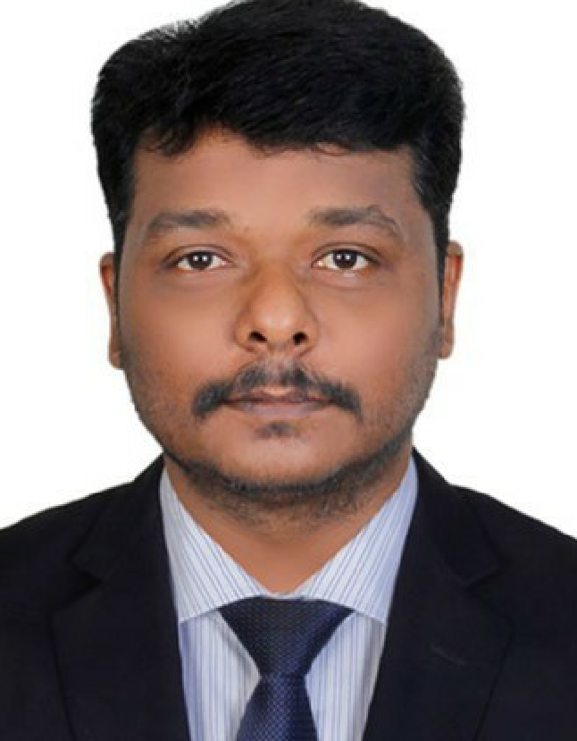
RAJESH
SENIOR PROFESSIONAL – POWER PLANT OPERATIONS
rajesh.381064@2freemail.com

Key Skills  Erection & Commissioning  Plant Operations & Maintenance  Strategy Planning  Safety Management  Technical Documentation  Vendor Management  Liaison & Coordination  Stakeholder Management  Project Management / Execution  Process Enhancement | Result-oriented professional with expertise in executing projects within budgeted cost and timelines; targeting senior-level assignments with an organization of high repute preferably in Gulf Region
 | Profile Summary
- Offering nearly 15.5 years of national & international experience in erection, commissioning, operations & maintenance of Power Plants
- Wealth of expertise entails High Pressure Boilers, Turbo Generators, Water Treatment Plants, Effluents Treatment plants, Environment Pollution Control, Cooling Towers, Diesel Generators and Vapor Absorption Chillers
- Administered entire power plant / site / boiler operations with key focus on planning, testing & commissioning of wide range of electrical and mechanical equipment
- Supervised operation & maintenance of power plant equipment and facilities, reduced downtime and increased plant availability, equipment reliability & operational efficiency by improving workflow, personnel performance and maintenance processes
- Key Resource Planner with hands-on experience in planning for manpower, material & money for successful completion of projects within time & budget constraint
- Effective in ensuring zero / minimum breakdown & maximum availability, thereby resulting in increased uptime; conducted Root Cause Analysis (RCA), implementing corrective actions and enforcing improvements to eliminate recurrence of breakdowns
- Displayed paramount efforts in addressing critical challenges head-on, strengthening workforce and accelerating performance at challenged operations
Career Timeline
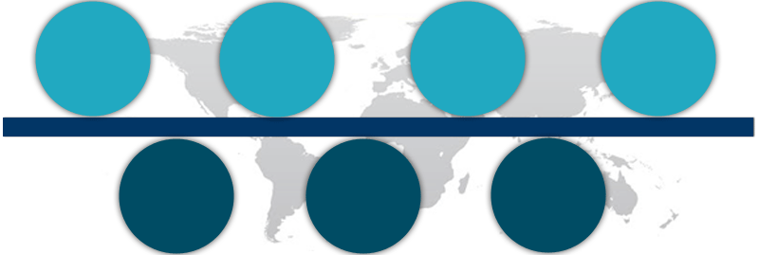
Jun’08 – Jan’10
May’02 – Dec’03
Shri Renuga Textiles Pvt. Ltd., Tamil Nadu as Trainee Engineer
Dec’03 – Apr’04
Om Shakthi Renergies Ltd., AP as DCS-Engineer
May’04 – Jun’08
M/s Hi-Tech Carbon, Tamil Nadu as Engineer - Utility
Thermax Ltd., Pune as Shift In-charge
Greenesol Power Systems Pvt. Ltd., Chennai as Assistant Manager
Jul’12 – Oct’14
Jan’10 –Jul’12
Thermax Ltd., Pune as Station Manager
Since Nov’14
AL Ghurair Resources LLC, Dubai as Site Manager
Education
- B.Tech. (Mechanical Engineering) from Dr. M.G.R. Engineering College, Chennai in 2007
- Diploma in Mechanical Engineering from DOTE, Chennai in 2002
Work Experience
Since Nov’14 with AL Ghurair Resources LLC, Dubai as Site Manager
Projects: Power Plant 1*8 MW (Under construction)
Steam Generators AFBC Boiler of M/s Uttam make - 01 Nos. (62 MT/H capacity, 66 Kg/cm2 press, 485 OC temp.)
Turbo Generators Air Cooled Condensed Steam Turbine of M/s SNM make–1 Nos. (8 MW with air cool condenser)
DM Water Plants 45 M3 OBR Ion Exchange Process of M/s INO Exchange make - 1 Nos.

Jul’12 – Oct’14 with Thermax Ltd., Pune as Station Manager
Projects: Operations and Maintenance of 1x25MW Thermal Power Plant
M/s Madras Cements Ltd. RR Nagar, 1x25MW Thermal Power Plant
Steam Generators AFBC Boiler of M/s Thermax make - 01 Nos. (110 MT/H capacity, 88 Kg/cm2 press, 515 OC temp.)
Turbo Generators Air Cooled Condensed Steam Turbine of M/s Siemens make–1 Nos. (25 MW with Air Cool Condenser)
DM Water Plants 12.5 M3 OBR Ion Exchange Process of M/s Thermax make - 1 Nos.
Effluent Treatment Plants - 250 M3/D of RO Plant of M/s Thermax make -1 No.
Diesel Generators 550 KVA with Cummins Engine of M/s NGEF - 01 Nos.

Jan’10 –Jul’12 with Greenesol Power Systems Pvt. Ltd., Chennai as Assistant Manager
Projects: 2x150MW M/s Ind-Barath Thermal Power Plant at Tuticorian Project
Designed BOP equipment; managed erection & commissioning of 2x480 TPH Thermal Power Plant Project for 2x150MW MW Power Generator Station of M/s Ind-Barath Thermal Power Project in technical collaboration with M/s Hangzhou Boilers Limited, China

Jun’08 – Jan’10 with Thermax Ltd., Pune as Shift In-charge
Projects: (C/o Chemplast Sanmar Mettur-Tamil Nadu) 2*25 MW Power Plant and M/s DCW Ltd., Sahupuram, Tamil Nadu, 2x25MW Thermal Power Plant
Steam Generators AFBC Boiler of M/s Thermax make - 02 Nos.
130 MT/H capacity, 88 kg/cm2 press, 515 OC temp. & 130 MT/H capacity, 88 kg/cm2 press, 515 OC temp.
Turbo Generators Condensed Steam Turbine of M/s TDPS make – 2 Nos.
25 MW with Air Cool Condenser
DM Water Plants 25 M3 OBR Ion Exchange Process of M/s Thermax make - 2 Nos. Effluent Treatment Plants
500 M3/D of RO Plant of M/s Thermax make -1 No.
Vapor Absorption Chillers 150 TR of M/s Enmax make - 2 Nos.
Diesel Generators 550 KVA with Cummins engine of M/s NGEF - 01 Nos.

May’04 – Jun’08 with M/s Hi-Tech Carbon, Tamil Nadu as Engineer – Utility
M/s Hi-Tech CARBON., Tamil Nadu
Steam Generators: Water Tube Boiler of M/s Thermax make - 3 Nos.
- 40 MT/H capacity, 44 Kg/cm2 press, 425 OC temp.
- 52 MT/H capacity, 44 Kg/cm2 press, 425 OC temp.
- 70 MT/H capacity, 44 Kg/cm2 press, 425 OC temp.
Fire Tube Boiler of M/s. Shellmax make -10 Nos.; 6 MT/H capacity, 17.5Kg/cm2 press, 215 OC temp. each
Turbo Generators: Condensed Steam Turbine of M/s Triveni + TDPS Make–3 Nos.
- 2.5 MW with Water Cool Condenser
- 6.0 MW with Air Cool Condenser
- 8.0MW with Air Cool Condenser
- 17.2MW with Air Cool Condenser
Effluent Treatment Plants
- 150 M3/D of RO Plant of M/s Thermax make -1 No.
- 100 M3/D of Oily water Plant of M/s Thermax make – 1 No.
- 48 M3/D of Evaporator Plant of M/s Macdha make – 1 No.
Vapor Absorption Chillers; 150 TR of M/s Enmax make - 2 Nos.
Diesel Generators; 1250 KVA with Cummins engine of M/s NGEF - 2 Nos.
Control System; DCS Centum CS 3000 of M/s Yokogawa, Japan

Dec’03 – Apr’04 with Om Shakthi Renergies Ltd., AP as DCS-Engineer

May’02 – Dec’03 with Shri Renuga Textiles Pvt. Ltd., Tamil Nadu as Trainee Engineer
Projects: Operations and Maintenance of 4.5 MW Bio-Mass Captive Generation Power Plant with DCS System
Company Profiles: Boiler Make – M/s. Chethar Vessels Ltd.; Type – Bi-Drum Water Tube – FBC Boiler; Pressure – 75 kg/cm2; Capacity – 26.5 Tones / Hr.
Turbine Make – M/s Triveni Engineering Industries Ltd., Bengaluru; Type – Nozzle Governed Bleed cum Extraction Condensing; Capacity – 4.5 MW

Key Result Areas:
- Undertaking erection & commissioning of Boilers, Turbo-generators, DM Water Plants, Effluent Treatment Plants and Diesel Generators along with commissioning of Chillers, Fire Tube Boilers and DCS
- Planning and executing preventive maintenance schedules of various equipment to increase machine uptime and equipment reliability; identifying areas of obstruction / breakdowns and taking steps to rectify same through application of troubleshooting tools
- Coordinating material / spare parts planning related activities encompassing identification of vendors, requirement specification & offer evaluation
- Preparing layouts for project as per the process and material flow needs; anticipating performance bottlenecks and taking corrective measures to avoid the same
- Supervising site preparations, mobilizing contractors for executing erection activities
- Managing erection, commissioning of Power Plants; coordinating for plant operations
- Deploying available resources to achieve organizational objectives; managing all technical & managerial aspects
- Developing maintenance, operations procedures to increase the efficiency; implementing standards and ensuring adherence to quality standards through in-process checks

Significant Accomplishments:
- Skill Soft E- learning L1&L2 level achieved from M/s Thermax Ltd. on 02/08/2012
- Received “Super Achiever Card- Platinum” from M/s Thermax Ltd. management for best energy saver in 2013
- Acknowledged with Super Achiever Card - Gold from M/s Thermax Ltd. management for best operation execution in 2008
- Worked as Shift In-charge of DCW Limited, Sahupuram (TN) Plant and was successful in achieving a higher availability of 98.5% along with productivity of equipment by 1.5%
- Troubleshot issues such as boiler LOI increase, reduction of fines in coal & coal feeder online cleaning system
- Managed time and budget for overhauling of BTG & BOP system during Annual Shutdown
- Successfully managed erection, testing and commissioning of 1x25MW Madras Cements Power Project
- Initiated successful development and implementation of VFD Application at CEP Pumps and Coal Crusher mechanism as well as the cost reduction 90000USD/annum activities related to ACC & CHS systems along with design selection & quality control activities
- Successful in reducing maintenance shutdown rate from 12% to 8% as well as saving maintenance costs by 2% through effective roll-out of On Sport Checklists and PM Schedule initiatives

Certifications
- Boiler Operation Engineers Certificate from Chief Inspector of Boilers, Tamil Nadu in 2017 (BOE)
- Certification of ISO9002, QS9000, ISO14001, OHSAS18001 and IQRS level; 7 award winner of TPM Phase-2 and Deming Prize
- Boiler Operation Competency Certificate from Chief Inspector of Boilers, Tamil Nadu in 2007 (1st Class)
- NEBOSH Certificate (IGC-1&2 U/P and IGC-3 Completed)
- First Aid - Senior Level achieved from M/s John Ambulance., Tamil Nadu on 11/01/2008
- Life Saver - Basic Life Support Certificate from M/s Usha Fire Safety Equipment (P) Ltd. on 02/08/2004
- Life Saver - Basic Life Support Certificate from M/s Usha Fire Safety Equipment (P) Ltd. on 07/12/2012

Personal Details | Date of Birth: 20th May 1982  Languages Known: Tamil, English and Hindi  Driving License Details: International valid (Place of Issue - Dubai)  Nationality: India  Visa Details: Work visa with Family Residence  Gender: Male  Marital Status: Married  Number of Dependents: 1

