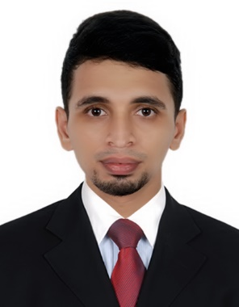  Personal Profile:  Name:  Nayeem  DOB :  27 Dec 1992  Sex:Male  MaritalStatus:Single  Nationality: Indian  Visa Status:Transferable  ADDITIONAL CERTIFICATES:  MCSA and CCNA  Certification(CMS Calicut,Kerala)  MOBILE PHONE SERVICING with A Grade (The Cellular Technology School Thalassery,Kerala)  Hobbies:  - Playing Football  - Planting Trees  - Traveling  - Helps who need help if I can  Languages Known:  - Arabic (Written)  - English (Written/Spoken)  - Malayalam (Written/Spoken)  4.Hindi/Urdu(Written  /Spoken)  5. Tamil (Spoken) | Email: nayeem.381077@2freemail.com  Location: Deira,Dubai  CAREER OBJECTIVE  Looking for a Position as anComputer engineer in a reputed organization which will give me the opportunity to use my knowledge and skill in my profession, to work towards the growth of the organization.  WORK EXPERIENCE  Network/System Administrator CMS Ltd., Calicut, India  01/2017 – 12/2017  Responsibility:  Set up new users in Microsoft Windows Active Directory and LDAP. Administration of Cisco equipment and Conﬁgured IT LAN/WAN elements. Held responsibility of maintaining and monitoring performance of network.  Desktop Support Engineer BizzIT Solutions, Kerala  07/2016 – 12/2016  Responsibility:  Install, conﬁgure and maintain computer systems (servers, printers, computer workstations, etc.) and telephones. Hardware Maintenance and Repair. Plan and execute allotted work within deadlines.  Desktop/Hardware Support Engineer Repair & Return(R&R),Bangalore  11/2014 – 06/2016  Responsibility:  Resolving hardware and software related issues of Laptops, Tablets. Repairing LCD televisions, Motherboards. Maintain records of daily tasks.  EDUCATION  Computer Engineering (2014)  NTTF, Bangalore  MCP (Windows Server 2012)  Certiﬁcation Number: G637-6053  MCSA (Windows Server 2012)  Certiﬁcation Number: G638-6611  PROJECTS  HMT Marketing (ASP.Net and MySQL)  Career Guidance System (VB.Net and MySQL)  ATTRIBUTES  - Communication  - Client Relationships  - Adaptability  - Critical thinking  SKILLS  - Windows Server Administration  - Managing Active Directory users  - CCNA R&S  - Router and Switch Conﬁguration  - MS Outllook, Word, Excel & Power point  - MOBILE PHONE SERVICING  Declaration:  I hereby declare that the information furnished above is correct to best of my knowledge and reference shall be up on your request.  Nayeem

