BASIL
Basil.381083@2freemail.com
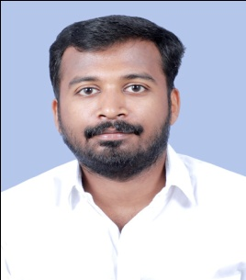
Resume
Date of Birth Nationality Location
6th OCT 1991 Indian Dubai

PROFILE SUMMARY
- Self motivated and motivator
- Expert in driving (Looking forward for UAE driving license)
- Professional and neat
- Reliable and resourceful
- Interpersonal skills.

WORK EXPERIENCE: Worked as service provider in a supermarket:
- Excellent in customer servicing.
- Polite service provider.
- Trained in meeting customer requirements.
- Managed floor sales team.
- Checking on the product dates.
- Ensured proper arrangement and layout of the products.
- Patient in understating the customer needs.
- Directing the customers to concerned staff or sections.
- Creating customer loyalty by keeping good service history.
- Understanding the ability of the staff and reassigning to their expertise areas.
PERSONALITY TRAITS
• High Grasping Power.
• Keen Intellect.
• Can work under pressure to meet deadlines.
• Flexible team player

AWARDS & ACCOLADES
- Member of youth welfare association, Palakkad.
- Programme coordinator for several arts fest, union inauguration etc.

EDUCATION
QUALIFICATION | INSTITUTE/BOARD | PERCENTAGE
DIPLOMA | JUNIOR DIPLOMA IN COMMERCE | 55%
12 | ASMM HSS, ALATHUR | 58%
10 | MM HSS Panthalampadam , Palakkad | 68%

PERSONAL DETAILS
Date of Birth: 06/10/1991
Gender: Male
Nationality : Indian
Visa Status: Visiting Visa
Languages Known: English, Malayalam and Tamil.

Place: Dubai

