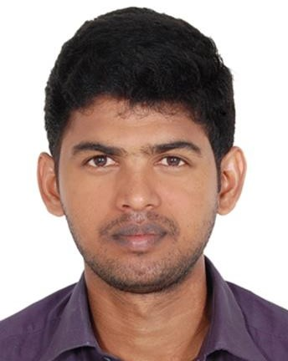

OBJECTIVE
HARI

E-mail: hari.381097@2freemail.com

To continue my experiences, innovative ideas, knowledge and hard work to implement a system "Best in Practices" that will benefit the Organization for the growth and overall Organization efficiency

EDUCATION QUALIFICATION

B.E., Graduate in Electronics and Instrumentation KLN College of Engineering, Anna University, Chennai (2010-2014).

EMPLOYMENT SYNOPSIS

    - Worked as a quality engineer in Daebu Automotive Seat India Pvt Ltd., Chennai(JAN 2015 to APRIL 2016)

    - Worked as a quality engineer in Renuga IndustriesChennai(MAY 2017 to JAN 2018)

PROFILE SCAN

    - Designing the job as per customer specifications and sending it for production process.

    - Assessing the quality of the product and preparing inspectionreport.

    - Prepares reports by collecting, analyzing, and summarizing data; making recommendations.

    - Finding the cause of the defect and develop asolution.

    - Maintaining the documents like MSA, SPC, Product audit and Processaudit.

    - Designs systems by which production quality can be checked in an ongoingprocess.

    - Production team to implement any new testing criteria or assembly methods they may have developed.

CERTIFICATION COURSES UNDERGONE

    - Pipe Stress Analysis usingCAESAR-II
    - Aveva PDMS12.1

IMPLANT TRAINING

Undergonetraining for Piping Fabrication and Machining in TCC Travancore Cochin Chemicals.

AREA OF INTEREST

PlantDesigning, Pipe Modeling, Equipment Modeling, Pipe Designing, PipeRouting

EXPERTISE
      - PDMS
      - CAESAR
      - PRIMAVERA

PERSONAL DETAILS

Date of Birth : 08thMay1993
MaritalStatus : Single
VISA Status : Visiting Visa
Nationality : Indian

CommunicationSkills : Tamil, English ,Malayalam

DECLARATION

I, hereby declare that all the information provided above are true, correct and complete to best of my knowledge and belief.

