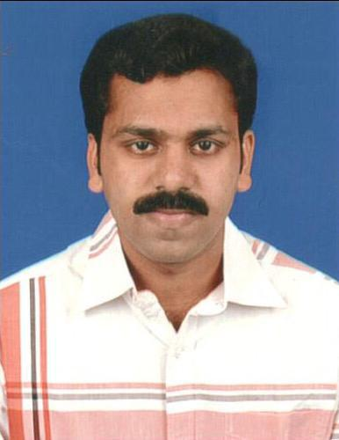

PREGITH

MSc ( Nursing )

Email: pregith.381098@2freemail.com

Nationality : Indian

Date of birth : 07/01/1986

Gender : Male

Marital status : Married

Religion : Christian

Languages Known

English, Malayalam, Hindi, Kannada

Passport Details

Place of Issue | : Trivandrum
Date of Issue | : 05/01/2017

Date of Expiry : 04/01/2027

Visa Details

Visa Status : Visit Visa

Curriculum Vitae

OBJECTIVE:

Seeking an opportunity to work with your esteemed institution contributing to the fulfillment of the institutional objectives by utilizing my skills and abilities & ensuring personal growth while being resourceful, innovative and flexible.

FOR THE POST : PATIENT RELATION OFFICER / WARD CLERK/MEDICAL RECORD DEPARTMENT

WORK EXPERIENCE SUMMARY:

1. SIMONS NURSING ACADEMY,KERALA,INDIA

Duration : 05/02/2014 to 15/03/2018 ( 4 YEARS )

Designation : Administrative Officer

Department. : Administration

2. APOLLO HOSPITAL,AHMEDABAD,INDIA

Duration : 09/02/2009 to 26/03/2010

Designation : Staff Nurse

Working Section : Medical Surgical

CERTIFICATIONS:

- Registered Nurse

- Medical coding

PROFESSIONAL QUALIFICATIONS

 | Siddaganga College of Nursing, Bangalore
 | Rajiv Gandhi University of Health Sciences
MSc Nursing | Duration of Study: 2004 – 2008

BSc Nursing | Anirudh College Of Nursing,Bangalore
 | Rajiv Gandhi University of Health Sciences
 | Duration of Study: 2004 – 2008

PROFESSIONAL REGISTRATION

Type | License No. | Country | Date of Issue | Expiration
 |  |  |  | Date
Karnataka Nursing | 005919 | India | 10 February 2014 | Life Long
council( MSc Nursing)
Karnataka Nursing | 17446 | India | 01st April 2009 | Life Long
council( BSc Nursing)

EMPLOYMENT HISTORY

- Worked as a Administrative officer in Simons Academy,kottayam,kerala from February 05,2014 to March 15,2018.Simons Academy is an education institution for nurses to prepare HAAD,DHA,NCLEX & all Prometric exams.

- Worked as a staff nurse in Apollo Hospital,Ahmedabad from February 09,2009 to March 26 ,2018.Apollo Hospital is 400 bed Hospital

SKILLS AND STRENGTH

- Proficiency in MS office

- Maintaining Records and Reports
- Oral and written skills in communication
- Typing speed conformed to 45WPM
- Confident and Self motivated
- Can work under pressure
- Knowledge about medical terminolgy
- Ability to organize and implement work related activities
- Knowledge about Medical Record files

EXPERINCEACQUIRED

- General Administrative duties

- Handled Receptionist duties

- Maintained Files of Employees

- Maintained Attendance Management

- Coordination and Implementation of office procedures

- Handled external or internal communication systems

- Managing other clerical staff

- Organizing and arranging meetings and classes

- Teaching students-HAAD,DHA,PROMETRIC

- Joining and seperation formalities of employees

PROFESSIONAL SKILLS

- Assess overall needs of patients & allocate the available resources

- Leads nursing assisstants to provide optimal nursing care

- Assisst with orientation and introduction of new staff

- Receiving the patient,Medical administration

- Performance of CPR

- Managing medical and surgical cases

- Assisted various procedures

- Maintained all medical record files of patients

CERTIFICATION

- Advanced Certification in Medical Coding,Medical Billing

COMPUTER KNOWLEDGE

- MS office : word,power point,Excel

- Typing speed to 40 wpm

- Windows operating system

Declaration

I do here by declare that the above furnished details are true to best of my knowledge.

