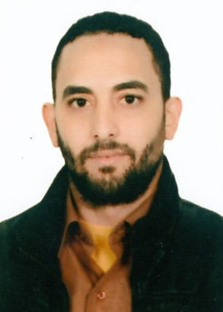

MOSTAFA

Mostafa.381100@2freemail.com
Tourist Visa
Cashier& Invoicing Operator -Four Years GCC Experience ( FordMotor )
Marital Status: Married
Date of Birth: 24 Dec 1988
Driving License: Qatari, Egyptian
USINGKARRIDGEAutoline System (CDK) more than four years.

WORK HISTORY

- Accountant/ Alexandria, Egypt(From 01-01-2011 To 25-11-2013)Three Years FMCG Experience.
at EL Shamadan Company for Food Industries .

- Head Cashierin GCC (Doha, Qatar)& From 11-12-2013 To 07-03-2018) Four Years and Three Monthsin Al Mana Motors Company (FordMotor).
EDUCATION
Bachelor of commerce(Accounting), Benha University, Egypt
SKILLS
- Communication Skills.
- Strong Interpersonal.
- Highly Organized.
- Body Language for Satisfying the Customers or to let them quite if they are angry for any matter.
- Good Follower with my Customers always in Supply and in Collection.
- Making Good Relations with my Customers as Friends.
- Computer Skills.
- MS Office (Word – Excel – Internet).
- Ability to work under stress.
- Looking for the best ideas to can improve the company.
- Problem Solver.
- Getting Good Satisfactions from the Customer.
- Email Skills
- Data Entry Skills.
- Quick Learner.
- Can Join Immediately.
- Can work anywhere in UAE .
Courses
- Course in a Successful Dealership from FORDMotor in 14-11-2016.
- Basic of Investment in Stock Market and Finance.(Held in July 2010 From Faculty of Commerce – Alexandria University.

