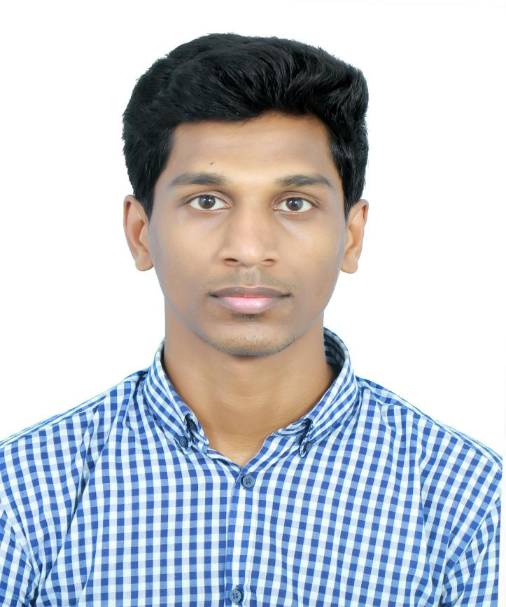
Binny

E-mail: binny.381115@2freemail.com

WORK

EDUCATION
Bachelor of Mechanical Engineering |  | Apr 2008 — Apr 2012
Anna University Chennai (India)
Concentrations: Mechanical - GPA: 6.5/10
Master of Business Management |  | Feb 2015 — May 2017

Riga Technical University, Latvia

Concentrations: Industrial Engineering & Management - GPA: 6/10

WORK EXPERIENCE/VOLUNTEERING

Production Shift Supervisor - Conares Steel, Dubai - Feb 2013 — Feb 2015

ROLE AND RESPONSIBILITIES

Company profile : Conares manufactures Rebars with a size range of 8 to 40 mm. The Rebar Mill has an annual production capacity of 500,000 MT per year. Being regionally & internationally certified, the rebars are accepted globally.

- Providing direct supervision to ensure the achievement of quality, production, safety and cost objectives; Managing, training and developing the hourly workforce;
- Ensuring adherence to company procedures, policies and the collective bargaining agreement;
- Ensuring compliance with safety and environmental requirements;

- Coordinating, planning and prioritizing daily department schedules, assignments, activities and priorities;
- Troubleshooting operational issues and identifying corrective measures; Practicing continuous quality improvement;
- Supervising scheduled repairs and distributing work orders; And participating in special

projects as assigned.

- Demonstrated mechanical maintenance experience / knowledge is required.

- Overall in charge of Rolling mill, Cooling Bed & Furnace.

- Operation-Rebar BAR 8mm to 40mm size & ROUND BAR and STRIPS mill Operation. Daily production planning & DPR analysis, finding gap For continuous Improvement, manufacturing cost Analysis, MIS report, prepared budget for monthly Consumable & spare list. Cost control. Yield % Improvement up to 95% to 96 % wrt RM. Men power Handling. Subordinate development.

- Experience in rolling mill operations and related equipment (R.B.U; stand building, roller

guides, loopers, shears, mill adjustments, etc.)

- Experience with six sigma and / or continuous improvement practices ideal.

UCAT

PERSONAL SKILLS

- Turning ideas into profitable & sustainable business..

- Time study & cost analysis.

- Process Improvement Skill (Continuous Improvement)

- Result oriented, Successful pass ISO audit as a Management Representative

- Exp. In SAP / ERP, Project.

- Knowledge 5S, SIX SIGMA, KAIZEN, TQM, HSE/OSHAS.

- Certification in NDT methods on Radiographic Testing (RT) Level 2, Ultra sonic

testing (UT) Level 2, Magnetic Particle Test (MT) Level 2, Liquid Penetrant Testing (PT).

- Certification in Process Piping Engineering (as per ASME B-31.3)

- Certification on Mechanical CADD.

- Certification in AVEVA Plant design management system 12.1 Foundation, Equipment, Pipework, Structural & HVAC Modelling.

PERSONAL PROFILE

Visa Status | Visit Visa
DOB | 1990/5/26
Sex | Male
Nationality | Indian
Marital Status | Single

