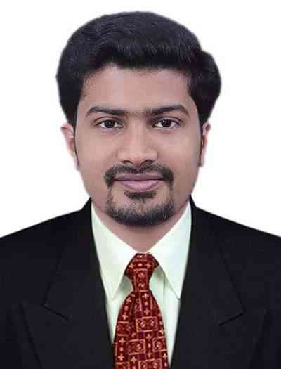
Deepak
Mechanical Engineer

PERSONAL SUMMARY

Mechanical Engineer with 3 years of comprehensive knowledge of designing, developing and execute projects to required specifications, focusingon reliability, quality and safety.
Friendly by nature and able to get along with colleague and senior managers
andcurrently looking for a suitable engineer position.

WORK EXPERIENCE
PERSONAL DETAILS
Email: deepak.381116@2freemail.com
DOB:18/03/1989
Nationality: Indian

AREAS OF EXPERTISE
3-D Modeling
ISO extraction
Drafting
Fabrication Drawing
Solid works, AutoCAD

- Indian Space Research Organization(ISRO),
Vikram Sarabhai Space Centre(VSSC)

MECHANICAL ENGINEER (OnContract)March 2015 to April2018

Project: Manned Mission

Duties and Responsibilities:
- 3-D Modeling of aerospace components using Solid Works
- Generation of virtual assemblies of 3-D components using Solid Works
- Extraction of 2-D drawings using Solid Works
- Preparation of fabrication drawings using AutoCAD
- Preparation of Technical documents and presentation

2. College of Engineering, Trivandrum
GUEST LECTURERDecember 2014 to March 2015

Duties and Responsibilities:
- Taking Lectures for B.Tech students
- Assist Professor in Lab session
- Assist Department in conduct of Exams

PROJECT/TRAINING PROFILE

- M.Tech thesis on “Determination of Coefficient of Discharge of mechanical fuel injection nozzle with varying needle lifts and orifice features”
- B.tech project on “Development of Patient Transfer System”
- In-Plant Training in Titanium Dioxide Pigment Unit ofK.M.M.L,Kerala, India.
- Certified AutoCAD Professional from CADD Centre

ACADEMIC QUALIFICATION

Degree | University/Board | Year | Marks%
M.Tech-Automotive Engineering | Vellore Institute of Technology&ARAI | 2012-2014 | 7.90 (CGPA)
B.Tech-Mechanical Engineering | Amrita ViswaVidyapeetham | 2007-2011 | 7.55 (CGPA)
12TH Grade | C.B.S.E. | 2005-2007 | 89.2
10TH Grade | C.B.S.E. | 2004-2005 | 85

PERSONAL SKILLS
Attention to detail
Time management
Good Team player
Problem Solving

AREAS OF INTEREST
CADD

HOBBIES/INTERESTS
Gardening
Acting

LANGUAGES KNOWN
English
Hindi
Malayalam (Native)
Tamil

ACHIEVEMENTS AND EXTRA-CURRICULARACTIVITIES

- Managed national level cultural and technical festivals in college as the central coordinator and member of the core-management team
- Event manager of “Lakshya”,the Mechanical graduate club ofAmrita College of Engineering

KEY SKILLS AND COMPETENCIES

- Experience in preparing GA and ISO drawings and reports
- Ability to explain technical design ideas clearly
- 3 years’ experience in SolidWorks 2016 and AutoCAD
- Basic Level knowledge in UNIGRAPHICS and CATIA 3-D EXPERIENCE
- Self-motivated with a positive and friendly nature
- Good communication skills

DECLARATION

I hereby declare that the above-mentioned details are true to the best of my knowledge and belief.

