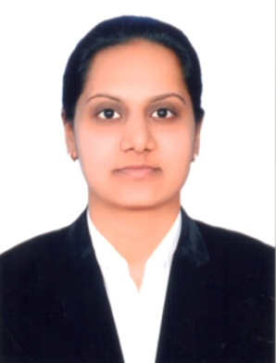
CURRICULUM VITAE
Khyati
Khyati.381131@2freemail.com

CAREER OBJECTIVE
“To work in a challenging environment where my knowledge and experience can be shared and enriched”.

PROFESSIONAL EXPERIANCE

Jet Point Computer Education Institute, Vyara.
Working Period: Sept-2012 to Dec 2012
Department: Software Lecturer: C, C++, TALLY ERP9, Coreldraw, ADOBE Photoshop. MS-Office.

- Achievers Computer Education Institute, Songadh
Working Period: Jan-2013 to July 2016.
Department:Software & Hardware Lecturer:
Fundamental Of Computer, MS office, C++ Tally, CorelDraw, ADOBE Photoshop, HTML.
EDUCATION

Exam | Board/ University | Marks (%) | Year Of Passing
B.C.A. | Veer Narmad South Gujarat University, Gujarat | 55.75% | 2012
12th | Gujarat Secondary & Higher Secondary Education Board, Gandhinagar, Gujarat | 65.00% | 2009
10th | Gujarat Secondary & Higher Secondary Education Board, Gandhinagar, Gujarat | 65.23% | 2007

ACADEMIC PROJECTS
Bachelor of Computer Application (B.C.A)
Title: E- shopping Mall
Frontend: Dreamweaver
Backend: MYSQL
E- Shopping mall is the web based shopping mall where user can shop by this site. The main purpose of the e-shopping mall is to advertisement of their product.

COMPUTER SKILLS:-

SOFTWARE SKILLS:
- C,C++,HTML,ADOBE PHOTOSHOP,CORELDRAW,TALLY ERP9

HARDWARE SKILLS:
- Having knowledge of all hardware Components.
- PC Formatting With Windows 7, Windows 8 Operating System.
- PC maintenance troubleshoot and Hardware assembly.

PERSONAL DETAILS:-
 | Name : | Khyati
 | Gender: | Female
 | Caste: | HINDU
 | Husband Name: | Mr. Vihang Dave
 | Date of Birth: | 19/06/1992
 | Languages Known: | English, Hindi, Gujarati
 | Nationality: | Indian
 | Visa Status | Currently on 3 months Visit Visa
 | Notice Period | Can Join Immediately

DECLARATION:-
- I do hereby declare that all the statements made in the application are true, complete and correct to the best of my knowledge and belief.
Yours Faithfully

Khyati

