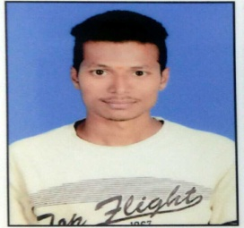

MADHU

Position applied for: Accountant, Data Entry Operator, Store/Time Keeping & Sales Sector
madhu..381148@2freemail.com
Bur Dubai, Dubai UAE.

CAREER OBJECTIVE:

To grow with and within the firm and to utilize my skill in an environment who offer’s mean opportunity to learn and grow. And to be a hand of winning team, which believes in the teamwork and give profitable result.

TECHINICAL SKILLS& COMPUTER KNOWLEDGE:

- PGDCA (MS Office (Excel, Word, PowerPoint & Access etc.)
- Accounting Package (Tally ERP, Focus, Wings etc.)
- Type Writing (25 Wpm)

EDUCATIONAL QUALIFICATIONS:

- Graduation: B.Sc. MPCS (Mathematics, Physics & Computer Science) Osmania University
- Intermediate in M.P.C with an aggregate of 72.7% from TRINITY Junior College Karimnagar(2011-2013)
- SSC with an aggregate of 74% from SFS High School(2010-2011).

PERSONAL COMPETENCIES:

- Self-confidence.
- Good Communication Skills.
- Dedication to work with Patience.
- Team oriented mind.
- Hard working, planning, and effective managing of time.

INTRESTED IN:
- Playing Cricket,
- Listening Music,
- Helping Others.

PERSONAL PROFILE:

- Marital status : Married
- Date of birth : 13/10/1994
- Sex : Male
- Languages know : English, Telugu and Hindi
- Nationality/Religion : Indian/Hindu.
- Visa Status : Visit Visa
- Temporary Address : Bur Dubai.

PASSPORT DETAILS: -

Passport Issue Date : 10-02-2017
Passport Expiry Date : 09-02-2027
Passport Issued Country : Government of India.

DECLARATION:

I hereby declare that the above information is true, according to my knowledge.

