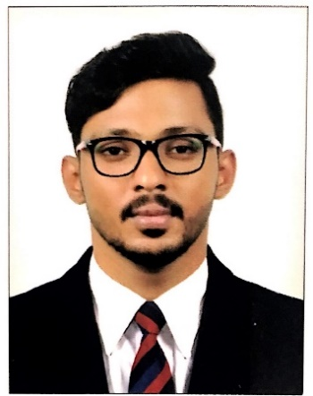
Sameer

Sameer.381153@2freemail.com

PROFILE SNAPSHOT

Challenging position in a professional and dynamic organization with an aim to contribute towards the objectives of the organization and simultaneously develop professional skills.

Competent and experienced professional with 7+ years of proven exposure within diversified Industries, Rich experience and expertise developed within Accounts, Finance, Internal Auditing, Administration

KEY SKILLS

- Accounting operations professional,
- Tax Accounting specialization,
- Fiscal budgeting knowledge,
- Cash flow analysis,
- ERP (Enterprises Recourse Planning) software,
- Strong Communication Skill,
- Accounting procedure consultant,
- Account Re conciliation specialist,
- Expert in statutory Accounts,
- Potential ability to work hard and perform under pressure.

PROFESIONAL QUALIFICATION

- IAB (International Association of book keepers)
- Computer Commerce
- Computerized Accounting with Tally, Peach tree, Wings Book Keeping, tac Easy, Navision, HIS Etc.
- MS Office, IOS, Internet, System Administration.
- Worked with graphic packages such as Photoshop, Page maker Etc.

AREAS OF EXPERTISE

Accounts, Auditing & Finance Management

- Preparation of Financial Statements included Profit & Loss, Balance Sheet, Cash flow & Statement of changes in equity.
- Deal with all general accounting and financial activities. Well rounded experience in controlling all financial
accounting activities of business together with senior management and group including timely preparation and
submission of financial reports.
- Prepare, review and analyze monthly/annual financial statements and audits.
- Handle complete books of accounts independently up to finalization,
- Responsible for verification, completeness and maintaining of accounting records.
- Accounts Receivables and Payables management

CAREER HISTORY (07 YEARS)
Nov-15 _ May 18 Good Shepherd International School
- Internal Auditor
- Computerized accounting with Tally & Navision
- Finance Analyzer.
- Registration, Students Fees Collection
- Purchase management
- Inventory management, Book keeping
- Day to Day management & Auditing
- Cash & Bank Day to day Management
- Suppliers and Contractors Managing
- Students Care, Payroll
- Statutory (EPF, ESI, GST, Income Tax etc.)
Aug 12_July 15 Asian Re Productive Medicine Centre
- Sr. Executive Finance
- Computerized accounting with Tally& Hospitality Management
- Finance management
- Inventory management.
- Day to Day management
- Cash & Bank, Credit Management
- HR & Staff Management
- Sales Tax, Income Tax
- Statutory Works (Provident Fund, TDS, Labour Tax, Insurance, ESI Etc.)
April 2011_July 2012 YOHANA COMPUTERS
- Accounts manual and computerized
- Inventory Management.
- Counter Management.
- Day to day management. Billing (purchase & sale)

EDUCATIONAL QUALIFICATIONS

- M COM (Master OF Commerce)
Indira Gandhi National Open University
- PGDIT (Diploma in International Business Operation
Indira Gandhi National Open University
- IAB (International Association of Book Keepers)
- B COM (Bachelors of Commerce)
University of Calicut

CERTICATION & REWARDS
- International Association of Book Keepers (IAB)
- Best employee of the year 2017-18

PERSONAL INFORMATION

- Date of Birth : 15/05/1992
- Sex : Male.
- Languages Known : English, Tamil & Malayalam
- Marital status : Single.
- Nationality : Indian.
- Hobbies : Gym, Dance &Listening Music.
- References : Available on request.

DECLERATION

  - I hereby certify that the above information furnished is true to the best of my Knowledge and belief.

