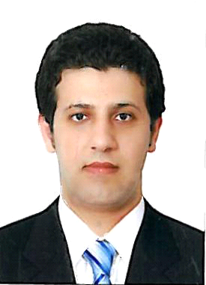
KASSEM
Email Add : kassem.381167@2freemail.com
Career objective
Looking forward to join a progressive organization where I can pursue a successful career by utilizing my skills, abilities and experience to the maximum extent with full potential. Being a professional I feel confident that I can achieve level performance which is nothing short to perfection.
EDUCATIONAL BACKGROUND
- Intermediate hotel institute from Syria
- Damascus Academy
- Employ of the month from alfardous tower
- Certificate of hygiene UAE
Summary of qualification
- Experienced in handing the cold section responsibly.
- Working around the section in the kitchen.
- Team player.
- Able to communicate between the section times in the pass of the kitchen.
- Able handle the store jobs and responsibility.
. Hygiene PIC certified level 3

WORK EXPERIENCE
Position : Sous chef in charge
Company : Ramada Hotel (Dubai, Deira UAE) and in charge
AS HEAD CHEF of reem albawadi restaurant branch
note. I started junior sous chef2012 then I got a promoted sous chef 2016
Year : 1 nov 2012 - UP TO PRESTE
Position : chef de partie (chef)
Company : PALACE HOTEL down TWON
Year : 7/10/2011 – 01/10/2012

Position : Cook (Demi Chef)
Company : Concorde Fujairah Hotel (UAE)
Year : 01/06/2010-1/10/2011
Position : Cook (Commi 1 Chef)
Company : Samad Al Iraqi Restaurants (UAE
Year :15/05/2009-30/05/2010
Position : Cook
Company : Alfardous tower HOTEL (Syria Damascus)
Year : 01/06/2008-01/04/2009
Position : Cook
Company : Bait Jadde restaurant (Syria Damascus old city)
Year : 01/06/2007-01/05/2008
Position : Cook
Company : Samira Miss Hotel (Syria Damascus)
Year : 15/07/2004-15/10/2005
Job Responsibilities:
- Prepares and cooks a variety of simple foodstuffs.
- Operates standard cooking equipment such as mixers, steamers, toasters, choppers, fryers, ovens and stoves.
Participates in kitchen cleaning work, such as washing and cleaning equipment.
- The chef will oversee the preparation of meals and ingredients, final presentation, sanitary issues and timeliness on the part of the employees.
- The chef is responsible for overseeing all individuals who work under their charge in the kitchen.
- Along with planning the menu, the chef is also responsible for creating the recipes and may or may not allow input from the assistant chefs.
- Prepares all menu items according to quantity menus.
- Bakes, roasts, broils and fries’ meat, fish and fowl.
- Mixes and cooks’ specialty dishes and delicate foods.
- Seasons foods by taste and recipe.
- Figures records of food used and supply on hand.
- Cleans and sanitized work areas.
LANGUAGE KNOWN
- Arabic: mother language
- English: write, read, speak very well
PERSONAL INFORMATION
Date of Birth : 22/04/1987
Nationality : Syria
Marital Status : Single
Gender : male
Religion : Muslim
Visa Status : Employment Visa

