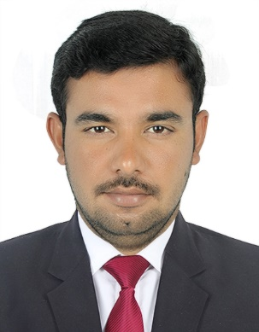
SHAHBAZ

Email: shahbaz.381183@2freemail.com

Visit Visa
CAREER OBJECTIVE:
To encourged creativity and higher order thinking to increase children performance.Having one year teaching experience at Army public school sarai alamgir, Pakistan.To build a long term career as a teacher with opportunities for career growth and to keep up with the cutting edge of the teaching technologies.
CAREER PROFILE/SKILLS:
- Patience and flexibllity.
- Strong communication skills.
- Keep abreast with the latest trends and best practices.
- Able to inspire, comfort, build self esteem.
- Self motivation, initiative with a high level of energy.
- Stress and time management ability.
PROFESSIONAL WORK EXPERIENCE:
Organization: Army public school and college sarai alamgir,Pakistan
Tenure: May 2017-April 2018
Designation: Secondary Teacher
Responsibilities:
- Designed and followed a complete teaching plan.
- Organized learning material and resources.
- Maintaining an open line of communication with parents and provide appropriate information.
- Assessing students performance and progress to ensure they are mastering the skills on regular basis.
- Cooperated with administration staff
- Following and complying with teaching standards and safety regulations.
- Monitoring children’s interaction and nature cooperation and sharing.
- Identified children’s individual and collective learning needs and planned, prepared and delivered instructions designed to capture students interest and maximize individual learning.
- Supporting students with individual Education Plans by appropriately scaffolding lessons while maintaining high expectations.
- Collaborating with other staff to create, implement, and co-teach engaging and creative lessons in which the students’learning styles and zones of proximal development were nurtured.
- To be punctual and be available in institutional working hours.

COMPUTER SKILLS:
- Well versed in MS OFFICE and MS EXCEL.
- Proficient in use of internet Browsing and Email
- Using the internet and Email services to meet the daily knowledge of subject.
- Good working experience of all kinds of computer hardware and software.
EDUCATION:
- BS(Hons) in chemistry from University of Gujrat, Pakistan 2017.
- F.Sc(Pre-engineering) from Gujranwala Board.
- Certificate for being the president of chemical society Jhelum, Pakistan
- Certificate of Laptop, awarded from Prime Minister due to remarkable GPA
LANGUAGES:
- English: Communicate clearly and concisely, both orally and in writing.
- Urdu, Hindi and other local languages of subcontinent.
PERSONAL INFORMATION:
- Date of Birth: 16 December 1993
- Nationality: Pakistani
- Marital Status: Single
Reference:
- Will be furnished on demand.

.

