Maher
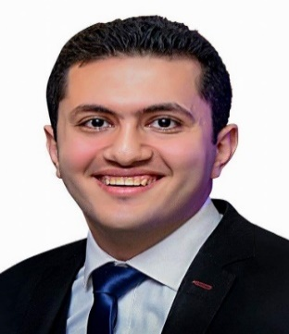
Personal Information
Date Of birth: 13-11-1993
Email: maher.381188@2freemail.com
Marital Status : single

Profile
I am an enterprising young professional intending to continue my development as anengineer. I think in terms of results and objectives, I am enthusiastic, and work with decisiveness and conviction,Excellent leadership, communications and interpersonalskills with good experience in dealing with different nationalitiesin multinational projects, Ability to perform on fast-track projects and to manage work under pressure.
Education&Training
2012-2017 :Bachelor of Mechanical Engineering.
University: HELWAN - Egypt.
Grade: Good.
Project Grade: Excellent.
Trained at Pfizer &Echem
Skills
●Using Autocad.
●Using solidworks.
Design Parts&Making assembly&Surface-Mold Design& Sheet Metal &Weldments&Making Layouts.
●CNCProgramming
Using Power mill software for Milling operations.
Using Edge cam Software for Turning operations.
●Microsoft office Program
Excel, word and Power point.

Languages
Fluent in Arabic (mother language)
Very Good in English
Slight knowledge in German
Professional Experiences
Worked at Super Pack Factory in Egypt(manufacturing packing machines) as a Professional Designer on solid works(Drawing new machines –create new parts from scratch –Modify machines –Making layouts ).

References Available Upon Request

