CURRICULAM VITAE

KISHOR

Dubai, UAE

E-mail: kishor.381196@2freemail.com

CAREER OBJECTIVE

Possessing 10 years of work experience in the field of construction industry, I am seeking a career in a reputed organization as an accomplished professional in the field to utilize my experience and knowledge and to offer my best for the further development of the company.

Working Experience 1
➢ Company Name |  | : Tess Projects and Developers private limited.
➢ | Site Details | : Construction of Government Medical College, Palakkad.
➢ | Designation | : Project Manager

- Major Responsibilities : Workmanship/quality of work, measurement verification, maintenance of record, co-ordination with engineers for clarification of drawings, rectification of drawings, and estimation of quantity as per drawings, co-ordination of procurement of materials.

➢ Duration |  | : June 2017 to Dec 2017
Working Experience 2
➢ Company Name |  | : Planex Projects and Construction private limited.
➢ | Site Details | : Construction of IIM Hostel Block (Phase IV) (1.2 Billion project)
➢ | Designation | : Project Manager

- Major Responsibilities : Workmanship/quality of work, measurement verification, preparation and maintenance of record, co-ordination with engineers for clarification of drawings, rectification of drawings, and estimation of quantity as per drawings, co-ordination of procurement of materials.

➢ Duration : August 2016 to May 2017

Working Experience 3
➢ Company Name |  | : KK Builders.
➢ | Site Details | : Construction of IIM Hostel Block (Phase IV) (1.2 Billion project)
➢ | Designation | : Project Engineer

- Major Responsibilities : Plan the delivery of the project at hand.

Manage the day-to-day working, utilization, implementation and technical consultants engaged on client assignments. From ensuring the correct material turns up before a job, to explaining the work ethics and activities to colleagues.

Report progress on projects by suitable media to sector management, maintain and update project reporting

Plan and arrange visits to existing and new potential clients, ensuring every client receives sufficient support to enhance their relationships.

Plan and arrange visits to existing and new potential clients, ensuring every client receives sufficient support to enhance their relationships.

- Workmanship/quality of work, measurement verification, preparation and maintenance of record, co-ordination with engineers for clarification of drawings, rectification of drawings, and estimation of quantity as per drawings, co-ordination of procurement of materials.

➢ Duration | : May 2015 to August 2016
Working Experience 4
➢ Company Name | : Engineering Projects (India) ltd, (A Govt Of India Enterprises)
➢ Site Details | : Construction of NIT Mega Hostel Block (Phase II)(1 billion
project)
➢ Designation | : Junior Engineer

- Major Responsibilities : Work supervision, workmanship/quality of work, measurement verification, providing detail measurement for bill preparation, preparation and maintenance of record, co-ordination with engineers for clarification of drawings, rectification of drawings, and estimation of quantity as per drawings, co-ordination of procurement of materials.

➢ Duration : April 2012 to May 2015

Working Experience 5
➢ Company Name |  | : M/s. Yojaka India Pvt Ltd Company Mangalore
➢ | Site Detail | : IIM Calicut project work(270 million project)
➢ | Designation | : Site Engineer

- Major Responsibilities : Work supervision, measurement verification, providing detail measurement for bill preparation

➢ Duration |  | : March 2011 to March 2012
Working Experience 6
➢ | Company Name | : M/s. ALIMAC Construction Company in Calicut, Kerala
➢ | Designation | : Junior Site Engineer

- Major Responsibilities : Work supervision, measurement verification, providing detail measurement for bill preparation

➢ Duration : February 2010 to February 2011

Working Experience 7

➢ Company Name : M/s. P.A.M.HABEEB & ASSOCIATES Engineering Consultants

➢ Designation : Site Engineer

- Major Responsibilities : Work supervision, measurement verification, providing detail measurement for bill preparation

➢ Duration : August 2007 to August 2009

Types of Projects Handled

Shopping Complex – High rise building.

Residential building including apartment and villas at various locations in India. Alhind Apartment SEAFORT site (17 floors) project. -Junior site Engineer. Crescent apartment MAYFLOWER site (14 floor) -Project Coordinator IIM Kozhikode, (MDP Block) (270 million project).-Site Engineer.

NIT Mega Hostel Project as (1 billion project)-Junior Engineer.

IIM Hostel Block (Phase IV) (1.2 billion project)- Project Engineer, Project Manager Construction of Government Medical College, Palakkad - Project Manager

Strength and Skills

- Effective Communication skills

- Ability to Work Under Pressure

- Decision Making

- Time Management

- Self-motivation

- Conflict Resolution

- Leadership skills

- Adaptability

- Teamwork

Personal Details:
Sex |  | : | Male
Date of Birth |  | : | 23rd April 1982
Marital Status |  | : | Married
Nationality |  | : | Indian
Passport Details.
Place of issue |  | : | Kozhikode-Kerala
Date of expiry |  | : | 15/12/2018

Language Proficiency

Language | Read | Write | Speak
English | ✓ | ✓ | ✓
Malayalam | ✓ | ✓ | ✓
Hindi | ✓ | - | ✓
Tamil | - | - | ✓

Educational Background

❖ Technical
- Diploma in Civil engineering Calicut, Kerala, India.

- Academic

  - SSLC :Passed under Govt: of Kerala

- Computer Skills

  - AutoCAD ( 2d & 3d )

  - Microsoft Office

  - Adobe Photoshop

My Portfolio

Alhind Seafort Apartment
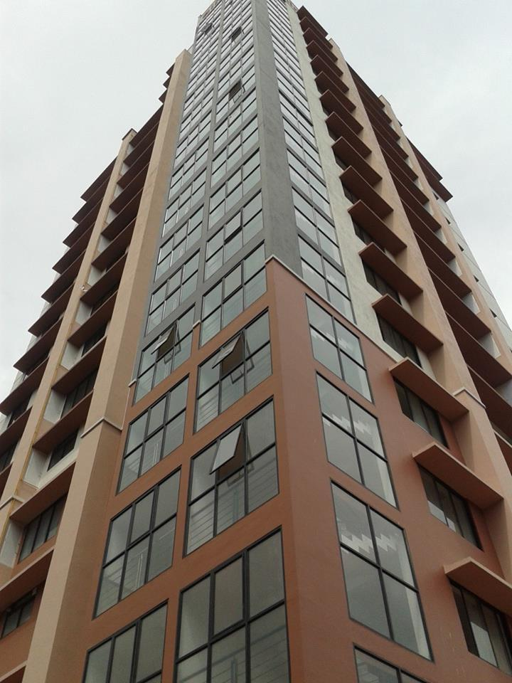

IIM Calicut project
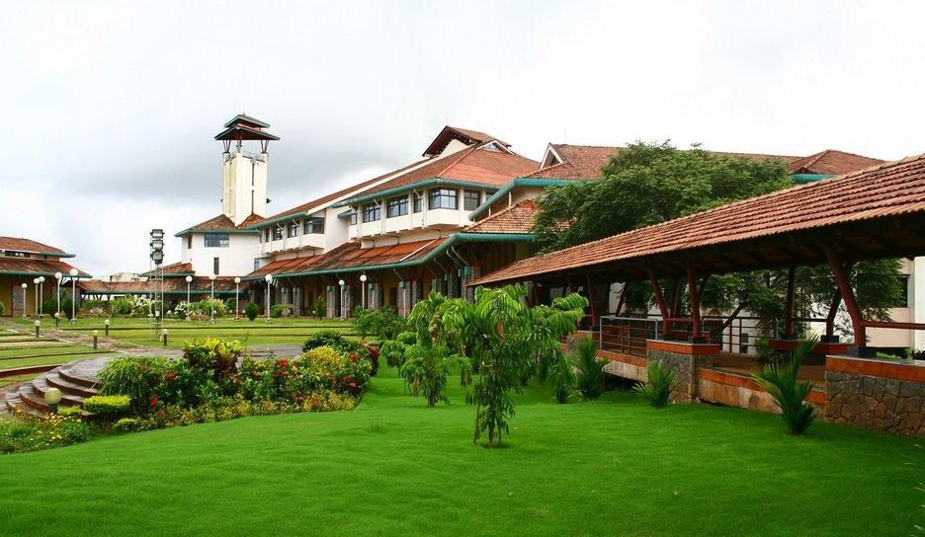

NIT Mega Hostel Block (Phase II)
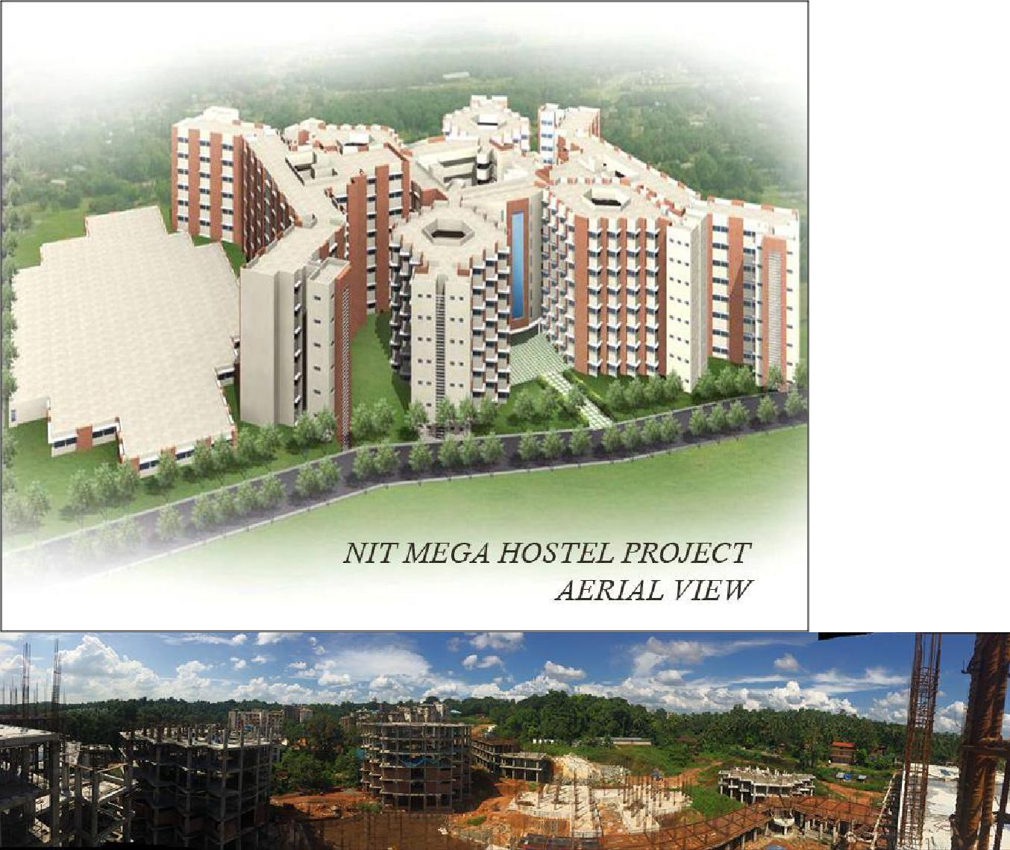

IIM Hostel Block (Phase IV)
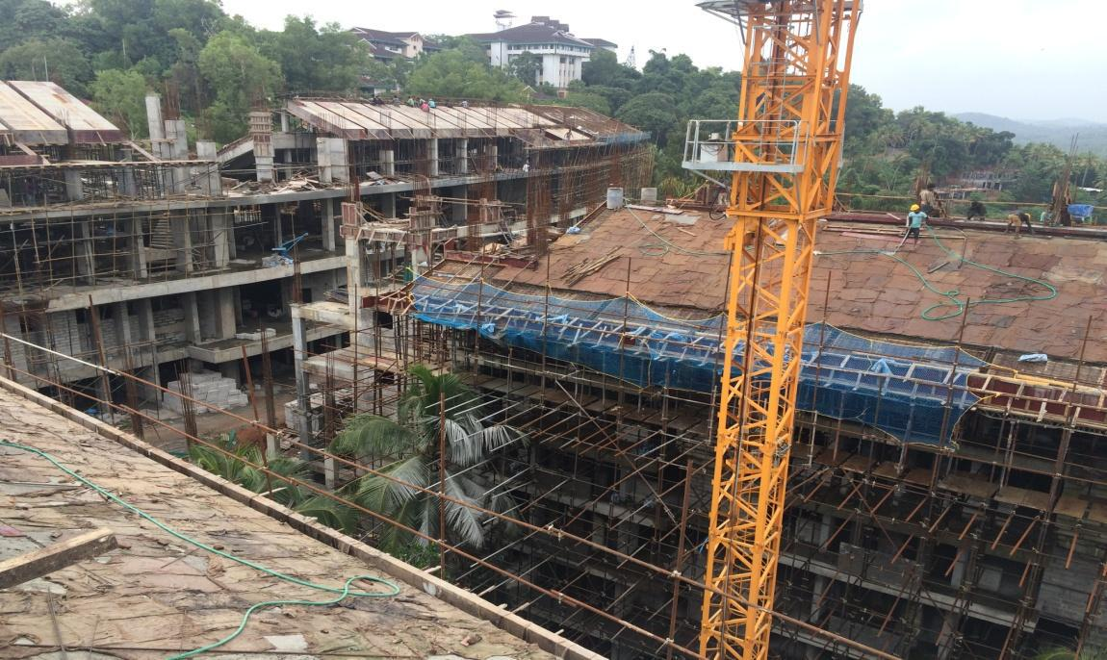

Government Medical College, Palakkad.
