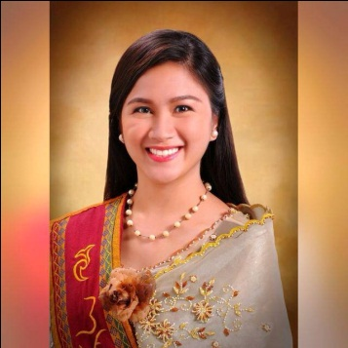
DARYL
Daryl.381199@2freemail.com
Dubai,United Arab Emirates

CAREER OBJECTIVE
To impart my knowledge and skills in psychology in which I can make an immediate contribution as an integral part of a progressive company. In this way, I can apply my business and educational experiences to assist the company in the accomplishment of its goals.
EDUCATION
University of the Philippines-Cebu (2011-2015)
- Bachelor of Arts in Psychology
St. Michael School (Quirino, Madrid, Surigao del Sur;Philippines 2007-2011)
- Graduated with honors
Madrid Central Elementary School (Linibunan, Madrid, Surigao del Sur, Philippines; 2001-2007)
- Graduated with honors

WORK EXPERIENCES

- IFP Manufacturing Corporation
HR and Admin Assistant
261 Kabatuhan Street, Deparo, Caloocan, Philippines
September 2016-December 2017
- Facilitates recruitment, selection and hiring of new employees
- In-charge of new employees’ orientation about Company Profile, Rules and Regulations
- Safe keeping of 201 files of all employees and other HR related documents
- Employee Relations
- Monitoring of attendance of employees

- Able Services Inc.
Subangdaku, Mandaue, Cebu,Philippines
HR Training Specialist
Setember 28, 2015-September 17, 2016
  - Plans and administers training programs to ensure that employees have the skills and knowledge needed for the job
  - Conducts Training Needs Analysis in order to design an effective Training Program
  - Conducts Employee Orientation
  - Administers Technical Training of Good Housekeeping

- Qualfon Philippines Incorporated
HR Recruiment Assistant
On the Job Trainee
April-May 2015
- Facilitates in conducting of Written and Online Examination of applicants
- Helped in filing of 201 files of employees

MEMBERSHIP IN ASSOCIATION/ORGANIZATION

- University of the Philippines Psychology Majors Association (UPPSYMA) (2011-2015): Member
- REPSYCHLES (2011-2015): Member
- Council of Leaders- University of the Philippines-Cebu PISO Batch Organization (2011-2015): Member

EXPERIENCES
- Conducted a Team building Activity (March 2013)
- Assistant to the Floor Director during the University of the Philippines-Cebu Cookout 2013
- Conducted A Focus Group Discussion (March 2013)
- One of the volunteers in 3-day Youth Camp in Madrid parish Church, Madrid Surigao del Sur (May 2009)
- One of the organizers in 1 week Youth Camp in Madrid Parish Church, Madrid Surigao del Sur (May 2010)
- On the Job intern at Qualfon Phillipines Incorporated (April-May 2015)

SEMINAR / CONFERENCES
- Critical Psychology Lecture Series (USC Main Campus-2011)

OTHER RELEVANT INFORMATIONS

- Was born on 22 June 1994
- Can speak Filipino, English, Cebuano and Surigaonon
- Has passion for playing volleyball
- Interests include in organizing, sorting, decorating things
- An advocate of peace and helping the poor
- Has a professional and approachable manner at all times
- Always willing to learn and try new things

