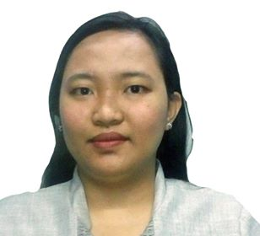
KRISTAL

E-Mailadd: kristal.381201@2freemail.com

Objective:
Pursuing opportunity which will allow me to grow professionally, while effectively utilizing my versatile skill set to help promote your corporation mission and vision.

Academic Background:
Tertiary: Bachelor of Science Business Administration major in Management
EulogioAmang Rodriguez Institute of Science and Technology
Sampaloc, Manila Philippines
(S.Y. 2011 to 2015)

Secondary: TimoteoPaez Integrated School
BalutTondo Manila, Philippines
(S.Y. 2007 to 2011)

Primary: Arsenio H. Lacson Elementary School
BalutTondo Manila, Philippines
(S.Y. 2001 to 2007)

Professional Experience:
Company name: Yakult Philippine Incorporation
Agoncillo Street, Ermita Manila, Metro Manila Philippines
Department: Yakult Marketing Corporation
Office Secretary
January 2016 to May 2018
- Receiving, filing and sorting daily reports
- In-charge for receiving and releasing of petty cash
- Preparing the bills to be send in accounting department
- The one to update the passbook and remit to the bank
- Answering customer’s inquiries thru telephone
- Invoicingand doing the receipt for the customers
- Preparing the daily inventory of stocks and monitoring the inventory of stocks using NAV system
- And also in-charge for the computation of the monthly commission of the staff.

Company name: St. Clare’s Medical Center
Dian, Street, Makati, Metro Manila Philippines
Department: Administrative Department
Administrative Staff
June 2015 to December 2015
- Process the admission of the patient
- Filing the documents of the patient
- Informing and explaining the patient about their bills in the hospital
- Process the certificates of the patient

Company name: National Bureau of Investigation
Taft Avenue, Ermita Manila, Metro Manila Philippines
Department: Office of the Assistant Director
On the job training/Volunteer
October 2014 to May 2015
- Filing and sorting the files
- Receiving the incoming and outgoing files
- Typing memorandum and closing reports

Highlights:
- Computer Literate MS Word, MS Excel, MS PowerPoint
- Friendly and I have positive attitude
- Responsible and reliable

Additional Information
Was born on March 28, 1995
Can speak Tagalog and English
Always willing to learn new things

