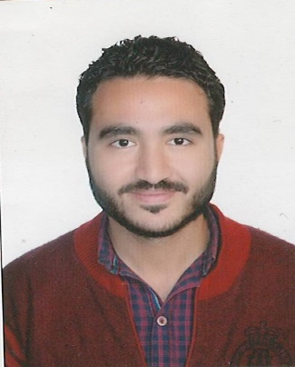
Ahmed

E-mail: ahmed.381213@2freemail.com
Address: Abu hail, Dubai
Objective "Icanworkindependentlyusingmyowninitiativeoraspartofateam.
ComputerSkills AutoCADSapMicrosoftWord
Revit Structure Etabs Microsoft Excel
PrimaveraSafe
Education BS in Civil Engineering Sep 2009 — Jun2014
New Cairo Academy, Egypt
Graduation Project: Concrete
Grade of graduation: Good
Workexperience
Housing &Building. National Rea. Cen.Oct.2016—Mar.2018
Consultant Engineering

Work on specifications for all items to get the job out impartially

Duties:

- Do all the tests to raise work efficiency.
- Receive all items from the foundation to final finishing.

Sakan for Consultant Eng. Bearu. Jun.2017— Mar.2018

Structure Design Engineering(partTime)

- Design of All Concrete Installations and The operation of the crisis tests
To product the painting economically and securely.

Duties:

- Output of all construction paintings with their own details.
- A preliminary inventory of all materials used in the project.
- Detailed review of old projects.

Alamalfor Contractor. Jun.2016— Sep.2016
Site Engineering

Responsible for working closely with the end client on various construction and civil engineering programs

Duties:

- Ensuring that all assigned work is completed on time and within agreed budgets
- Supervising Projects: including in house, external contractors and sub-contractor.

CoreCompetencies
Site engineering
Structure design engineering
Technical officer

Career Development
I always develop my Job Skills in construction and construction design
throughonline courses and also develop in engineering programs for
design and project management.
.

Personal information

Date of birth: Jan. 17th, 1992
Nationality: Egyptian
Marital status: single

