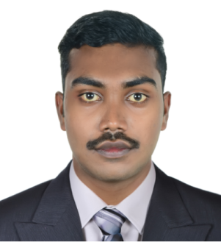
HASEEM
Email: -haseem.381218@2freemail.com

Objective:

To be able to accomplish a responsible position in organization where my skills, capabilities, experience and accomplishment will allow me for theopportunityrelated with career expertise and also to be able to exceed to the high standard of professionalism and quality service for the organization I may be associated with.

Experiance:
Company: Hercules trading LLC
Title: Office Boy (Part time)

Employee: Hercules trading LLC, Kerala, India
Period: From Feb 2015 – March 2016

Company: Falcon Glass palace.
Title: Office Boy(Full time)

Employee: Falcon Trading LLC, Kerala, India
Period: From July 2016 – Feb 2018

Education Qualifications:

Secondary School Leaving Certificate
Higher Secondary
Bachelor of Computer application – (2013-2016) - Completed

Languages:

- English (Speaking, reading and writing)
- Hindi (Speaking,reading and writing))
- Malayalam
- Tamil

Professional Software’s:

- MS Out look
- MS word,
- MS Excel,
- Power Point

Personal Detail:
- Name : HASEEM
- Date of Birth : 14/08/1993
- Gender : Male
- Visa Status : Tourist Visa
- Visa Expiry : July 20th 2018
- Nationality : Indian
- Marital status : Single

STRENGTH & SKILLS

- Fast learner willing to shoulder challenges and responsibilities.
- Maintain confidentiality while handling departmental related activities.
- Analytical thinking, planning.
- Problem analysis, use of judgment and ability to solve problems efficiently.
- Strong verbal and personal communication skills.
- Self-motivated, initiative, high level of energy.

Interests and Activities:
- Playing Cricket, playing volleyball, Games, Current affairs, Internet Surfing

