SUDHEER |  | PLANNING ENGINEER
Email | sudheer.381235@2freemail.com | 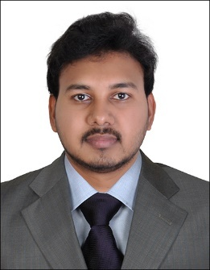

OBJECTIVE:
To join an esteemed and well-reputed organization with professional environment to utilize my best abilities to seek a path leading to growth oriented, dynamic, challenging accordingly rewarding career.

EDUCATION:

Bachelor of Technology in Civil Engineering with an aggregate 76%.
JNTU University, INDIA. May 2008 –May 2012

OTHER PROFESSIONALCOURSES:

MasterDiplomainBuildingDesign:Primavera,PPMConcepts,RevitArchitecture, STADD Pro. & AutoCAD2D

Certified Quality Control Engineer. (NDT LEVEL II)

TECHNICALEXPERTISE:

- Planning & Management Software: Primavera Project Management (P6 & P3 versions) and MS Project
- AutoCAD
- Advanced Skills in Microsoft Office

PROFESSIONALEXPERIENCE:

Dec 2015tillPresentTARGET ENGINEERING CONSTRUCTIONCO.

(ABU DHABI-UAE)
Planning Engineer- 2 years, 6 Months

RESPONSIBILITIES:

- Reporting to the Planning Manager
- Preparation / submission of Daily, Weekly & Monthly reports to Client and project progress on regularbasis
- Review,identifyandadviseprojectmanpower,equipment&otherresourcerequirements.
- Preparation / implementing corrective actions / recovery program to arrest slippage. Develop look-ahead schedules & identify requirements of manpower & equipment &materials.
- Developing the baseline construction schedule, resource loading, and preparation of Cash flows & Manpower Histograms.
- Coordinatewithsubcontractortofinalizeplanningrequirementsandcoordinatingbetweendifferent activities.
- AttendmeetingswithClients/projectmanagers&clarifyplanningstrategies.Reviewproject progress on regularbasis.
- Analyze productivity data and report to Project Manager asnecessary.
- Preparation / submission of Daily, Weekly & Monthly reports to Client and project progress on regularbasis
- Overall involve in general management of project life cycle from initiating, planning, executing, monitoringandcontrollingtillcloseoutwithintheconstraintsoftime,costandqualityandmakea tradeoff with optimizing available resources andrisks.

PROJECT:
- Integrated Gas Expansion Project, DAS ISLAND, Abu Dhabi.
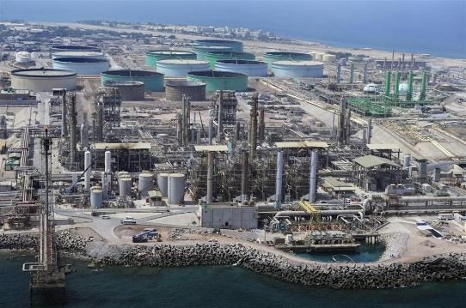
Abu Dhabi National Oil Company (ADNOC) is planning to transfer additional high pressure and low pressure gas from Habshan through Das Island. This new Development, which has been designated as Integrated Gas Development Expansion Project (IGD-E1) in Das Island, is being undertaken to fully utilize the available gas streams in order to increase the onshore gas supply. This work comprises of Civil, Mechanical & Electrical works where civil consists of Piling & Foundation works, Mechanical consists of Tie-ins, Stick built & Modular Structures and Electrical consists of Trenches, Substation etc.
MainContractor: Target Engineering & Construction Co.L.L.C.
Client: Abu-Dhabi Gas Liquefaction Company(ADGAS)
Consultant: Maire Tecnimont SpA
ProjectValue: Dhs 290Million

Dec 2013 to Dec 2015
TEPE AKFEN INVESTMENT CONSTRUCTION & OPERATIONS (DUBAI-UAE)
Junior Planning Engineer- 2 Years

RESPONSIBILITIES:

- Reporting to the Planning Manager.
- Daily visit to site to track the progress, monitor & evaluate day to day work progress by maintaining Daily Productivity report and alerting the site team about the low productivity.
- Updating the program every week, preparing weekly and monthlyreports.
- Monitor critical activities based on the project schedule and advise project management.
- Report to the Project Manager about the current work progress and make comparison between plan and actual progress and study impact of alternative approaches to work.
- Preparation of Action Plans for each trade of works like Block works, Plaster, Tiling etc. to complete on time.
- Ensureadequateresourcesareallocated,forthesuccessfulexecutionandtimelycompletionofthe project and withinbudget.
- Coordinating with the Construction Managers and providing them the Look ahead schedules.
- Coordinating with the Sub-Contractors for the updating of Subcontractor activities on weekly & monthly basis.
- Weekly site walk with the Client & Consultant to check the progress.
- Attending meetings with the Consultant to discuss the progress for the week after the site walk and notifying the site managers about the progress.

PROJECT:
- CONSTRUCTION OF DAMAC TOWERS BYPARAMOUNT, Dubai.
The project involves construction of a 4 towers each comprising a ground floor, 10 podium levels and 58 additional floors. The luxury project includes more than 1,800 units comprising approximately 1,000 one, twoandthreebedroomservicedsuitesandan800key,5- star ParamountHotel.

MainContractor: TAVConstructions.Client : DAMAC
Consultant: KEO InternationalConsultants
ProjectValue : Dhs 1.059Billion

June 2012 to Oct 2013RAVI RAMAN CONSULTANTS

(Hyderabad, INDIA)
Site Engineer/Planning Engineer- 1 Year, 4 Months

RESPONSIBILITIES:
- Responsibleforthe establishmentofplanningandschedulingforthe projectbyusingPrimavera.
- Managingthesiteengineersandcontractorsintermsofmaterials,drawingsanddesigntocarryout works as per siterequirements
- Managing change, identifying, formalizing and notifying relevant parties of changes inproject
- Calculatethequantities,ratesandgeneratethemonthlycashflowsrequirement.
- Reconciliation of all project activities on monthly basis andcompare.
- Prepare and demonstrate presentation to in-house top management personnel and checking actual progressagainstbaselineprogramandnegotiatethesolutionforresolvinganyirregularityinproject execution as perschedule.
- Develop and maintain estimating guidelines for work assignments, and assists with estimates for newprojects.
- Coordination with electrical and mechanical supervision engineer to meet the construction
Sequence and schedule and to avoid reworks.
- Attend various training programs, seminars on projectmanagement.
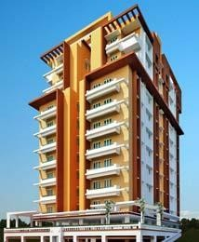

PROJECT:

- BHUVANASHEVERIAPARTMENTS

Ground +11 floors with 40 single, two and three bedroom apartments. Ground and first floor will be car parking, Hyderabad.
Client&Developer: VinayakaHomes
ProjectValue: Rs 200Million

PERSONAL DATA:

Nationality : INDIAN
Date of Birth : 31-Aug-1991
Marital Status : MARRIED
Children : One (Son)
Availability : Ready to start immediately
Home address : Hyderabad, India

