Name: sunil  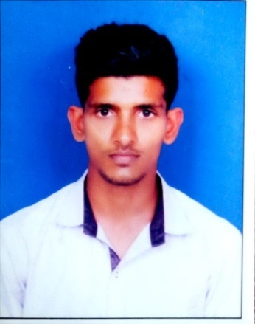  E-mail: sunil.381236@2freemail.com  Personal Data  Date of Birth:08/05/1992  Fathers Name:Raghu  Gender:male  Nationality: Indian  Marital Status:Unmarried  Languages known:  - English (Read/Write/Speak)  - Hindi (Read/Write/Speak)  - Kannada (Read/Write/Speak)  - Tulu (Speak)  Hobbies  Browsing of the Internet, Reading books, Playing outdoor games like football, cricket, volleyball etc. | RESUME  Objectives  To pursue a progressive career and to be associated with an organization that provides me scope to enhance my knowledge and skill.  Academic Qualification  Course Institution University / Board % or CGPA Obtained  MSc in Library and Information Science (2016) Dept. of Library and Information Science Manipal University 8.17  BBM Government First Grade College, Hiriadka Mangalore University 50%  PUC GPU College, Hiriadka State 52.17%  SSLC GPU College, Hiriadka State 51.48%  Technical Qualification  Operating System: Access of databases, Create a web page, access of software like EasyLib and entries in SPSS software etc.  Activities  Subjects Studied:DDC, CC, UDC, Cataloguing (AACR2 and CCC),web designing(html), Literature Search, ICT, Digital Libraries, Uploading publications to institutionaldigital repository(e-prints), database demonstration(subject area, search techniques, features, refining search results, etc.) as a part of the educational curriculum. Academic Libraries & Public Libraries.  Subject of Specialization: Field work report, Attended workshop on installation of open source library software Koha and Libsys.And workshop on EBSCO Database  Participation:Participated in one day state level conference at Mulki Sunder Ram Shetty Degree College Shirva.  Skills and Abilities  - To promote the importance of thelibrary in the community.  - To answer telephone calls and e-mails to satisfy various public queries.  - To recommend good reading material to increase the number of readers.  - Training new staff.  - To organize and coordinate different projects and services for the users.  - Acquistion of books.
Presented
- Presented a paper on “ Search Techniques In Electronic Databases : Skill For Information Professionals” at a 2nd National Conference on Management of Modern Libraries (NACML) -2016 Organized by KMC Health Science Library Manipal University, Manipal.
- Presented a paper titled “Makerspace in libraries to promote Entreprenuership : A conceptual study” at 1st International conference on digital entrepreneurship – 2018 Organized by SOM, Presidency University, Bangalore.
- Seminars as a part of Curriculum.
Personal Attributes
- Professionalism
- Enthusiasm
- Flexibility
- Leadership
Experience
- One year working experience as Librarian in S D M English Medium School (CBSE), Ujire.
- 6 months experience as Assistant Librarian at S.D.M Institute of Technology, Ujire.
- Presently working as Assistant Librarian at Presidency University, Bangalore.
Achievements
- Participated in NSS
- Participated in various intercollegiate tournaments Like Volley Ball, football etc.
I hereby declare that the information furnished above is true to the best of my Knowledge

