CURRICULUM VITAE

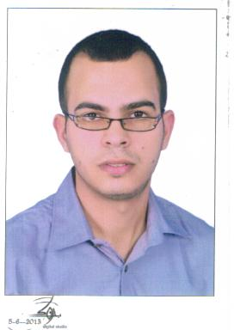
PERSONAL DETAILS

Name : Mohamed

Date of Birth : 20\9\1988

Nationality : Egyptian.

Email : mohamed.381261@2freemail.com

Marital Status : Married .

Military Service : NOT Wanted (Postponed) .

EDUCATION
- B.Sc. in Civil Engineering.
- Graduation year 2011.
- AlexandriaUniversity.
- Degree of graduation Accepted.

Personality
- Ambitious, Self motivated, Good team player, and hard worker.
- Auto Cad – Structural Design*Sap, Safe ,Etab* –Technical office- Primavera – SAP – OFFICE “Word , Excel”

Languages
 | Speaking | Reading | Writing
Arabic | Excellent | Excellent | Excellent
English | Good | Good | Good

E. Graduation Project
Mechanical of Soil Degree: GOOD

Summer Trainning
- Training at “ZAWBAA” for General Contracting
- Training in a company PROF.DR/M.IBRAHEEM for Consulting and Supervising

Experience
- worked at Attitude Towords Attitude for Real Estate in Jeddah, Saudi Arabia (Site engineer)
- worked in Saudi Arabia in Door Almabani for trading&Contr.co.
- worked in Saudi Arabia in kingdom Bridges forGeneral Contracting (Subcontractor within Saudi Aramco) .
- Worked as a Site engineer in a company Saleh Al Yahiacompany(Engineer Surveyor).
- Worked with Subcontractors in metro Projects (Site engineer in a company Kazzaz General Contracting) .
- Worked as a Site engineer in a company PROF.DR/M.IBRAHEEM for Consulting and Supervising.

