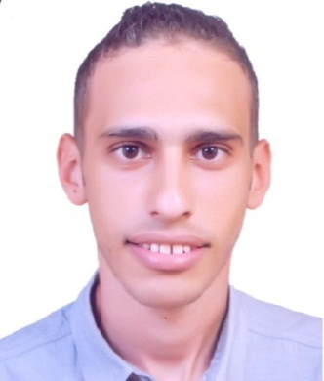
Ismail
Email: ismailelsayed28@gmail.com

Education
Degree: Bachelor of civil engineering

Graduation year: 2016

General Grade: Good, GPA: 2.66, Percent: 74.5 %

University: Suez Canal University-SCU

Project: Soil Foundation, Grade: very good (B+)
Experience
- El Banaa for construction (From June 2016 to August 2017 )
Site engineer
  - Check plans and drawings to ensure all calculations are accurate.
  - Making sure materials used are as specified in the contract.
  - Overseeing health & safety and quality control measures on the site.
  - Liaising with professional staff.
Preparing reports as required.

- EL-HODA for Construction & supplies (From October 2017 To present )
Design engineer
  - Responsible for Shop Drawing.
  - Use specialized software (AutoCAD, Sap, safe, Etabs).

- Trainee, Arab Contractors Company ( From June 2013 To September 2013 )
Site engineer
- Overseeing building works.
- Checking technical designs and drawings.
- Supervising of the concrete mixing.

- Trainee, Hassan Allam Sons (From June 2014 To September 2014 )
Site engineer
- Analyzing information and evaluating results to choose the best solution.
- Knowledge of materials, methods, and tools involved in the construction.

Courses
- AutoCAD
Course outlines
  - Introduction to AutoCAD
  - Basic Drawing Tools
  - Drawing Precision
  - Making Changes
  - Drawing Organization
  - Blocks
  - Advanced Editing
  - Printing
- Sap
Course outlines
  - Object Based Graphical Interface & Coordinate systems
  - Material properties
  - Types elements
  - Joint constraints
  - Display and output
- Preparation Engineer Safe & Etabs
Course outlines
  - Advanced AutoCAD
  - Analysis of beams
  - sap model
  - Design columns
  - ETABS model
  - Calculation sheet
Skills
- Computer skills:
- Microsoft office.
- Good User of Internet.
- Language skills
Arabic: Native Language.
English: Excellent.
Personal Data
Marital status: single.
Military status: Exempted.
Nationality: Egyptian.
Birth Date: 28/11/1992.

