RESUME
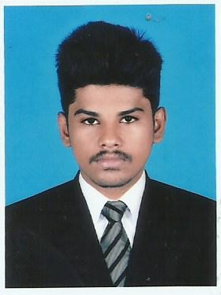
Jaisharan
Email-Id: jaisharan.381288@2freemail.com

CAREER OBJECTIVE:

My goal is to become associated with a company where I can utilize my skills and gain further experience while enhancing the company's productivity and reputation.

EDUCATIONAL QUALIFICATION:

COURSE | INSTITUTION | BOARD/ UNIVERSITY | YEAR OF PASSING | AGGREGATE (%)
B.E  ( Civil Engineering) | A.V.C. College of Engineering, Mannampandal, Mayiladuthurai. | Anna University | 2018 | 60%
HSC | A.R.R Matriculation Higher Secondary School, Kumbakonam | State Board | 2014 | 65%
SSLC | Christ the King Matriculation Higher Secondary School, Kumbakonam. | State Board | 2012 | 61%

TECHNICAL SKILLS:

- Area of Interest: Repair and Rehabilitation, Land Survey, Construction.
- Software known: Auto-CAD. Ms Word, Excel.

PROJECT:

MINI PROJECT: Design and analysis of box culvert.

Road leveling and Box culvert with in sloping portion 1:60 content of design of Auto CADD and Stadd pro.

MAIN PROJECT: Partial replacement of sand by egg shell and quarry dust in concrete

The present experimental investigations have been made on concrete using Quarry dust and Egg shell as fine aggregate and observed the effects of crushed Quarry dust and Egg shell on strength properties of concrete. The percentage of replacement are 10%,20%,30%,40%,50% in Egg shell and Quarry dust with river sand.

CO-CURRICULAR ACTIVITIES:

  - Undergone to Work shop on Fundamental principles of Health & Safety Management in A.V.C College of Engineering, Mannampandal, Mayiladuthurai
  - Undergone Workshop on Analysis of Stadd Pro. In A.V.C college of Engineering, Mannampandal, Mayiladuthurai.
  - Participation in paper presentation, CADD Modeling, Code cracking in K.S.K College of Engineering, Kumbakonam.
  - Undergone to Work shop on Strengthening of existing structures. in SIR Issac Newton college of Engineering and Technology, Nagapattinam.

EXTRACURRICULAR ACTIVITIES:

    - Participated in inter college modeling in create bridge structure.
    - Won many prizes in Carom, Chess, karatae, shuttle competition.

HOBBIES:

- Listening songs
- Playing games
- Driving

PERSONAL SKILLS:

- Honest and hardworking.
- Thrive on working in a challenging environment
- Good leadership as well as coordination with team

PERSONAL INFORMATION:

Course Undertaking : B.E- Civil Engineering
Gender : Male
Date of Birth : 20-07-1997
Nationality : Indian
Languages known : Tamil, English.
Marital status : Single

