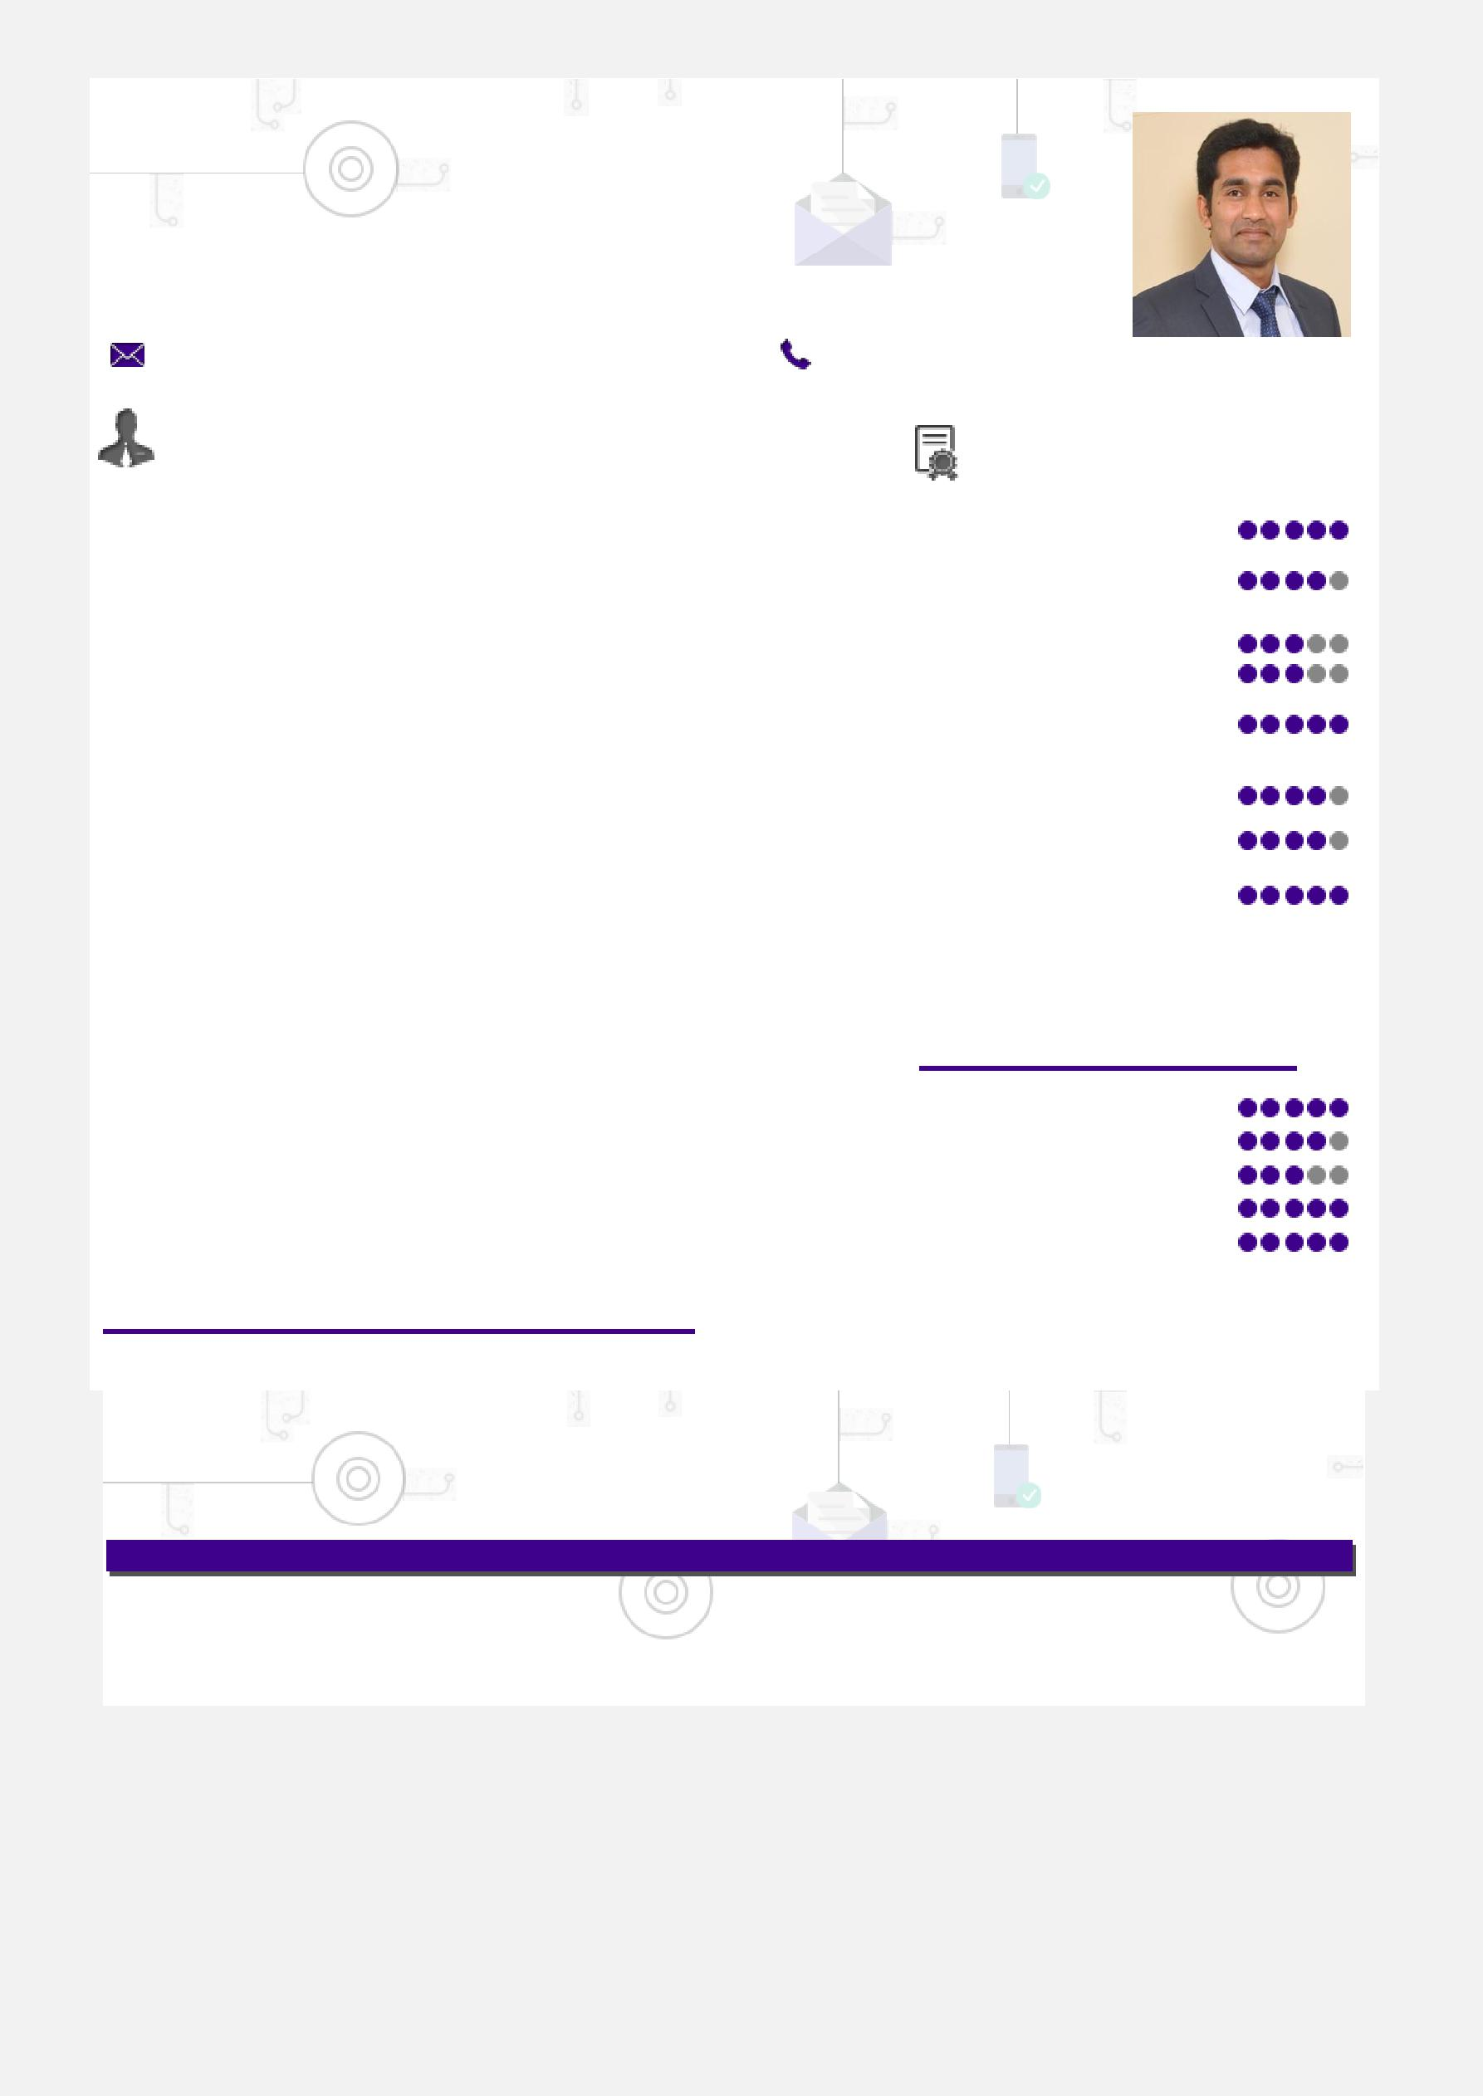
BALAMURUGAN

Plant Operations (Maintenance) / Project Management

Enthusiastic & high-energy driven professional targeting assignments in Project Management / Maintenance with an organization of repute across PAN India / UAE / Singapore /Australia

Balamurugan.381304@2freemail.com
Profile Summary |  |  |  | Core Competencies

- A result-oriented professional with nearly 7 years of experience in

Plant Operations and Maintenance, Production Planning and Project Management

- Excellent in coordinating, planning & implementing changes to technology, machinery, equipment, process methodology, control systems and reporting procedures

- Administered project activities from conceptualization to execution including business definition, feasibility and optimization, project planning, implementation, site management and manpower planning

- Expertise in production operations & shift management to facilitate smooth functioning of overall production operations & enhance operational efficiency

- Experience in managing diverse plant operations such as strategic plans, process & equipment selection, commissioning, capacity planning, process control, cost management & quality assurance

- Proficient in preparing & implementing quality checks to conduct incoming, in-process & final inspection on various products, process & procedures as per ISO: 9001 check list

- Exposure of liaising with Statutory bodies such as Electrical Inspector, Local Industrial Development Corporation, State Electricity Board and
PWD

Timeline

Strategic Planning Preventive and

Predictive Maintenance

Troubleshooting Equipment Handling

Quality Management
Negotiation & Contracts

Purchase Operations

Project Management

Team Building &

Leadership

Key Skills

Communicator Motivator Innovator Analytical Collaborator

 |  |  |  |  |  |  | Multitech
 |  | Diploma in Electrical &
 |  |  |  |  |  |  | Automations as |  |  |  |  | Terrazzo Dubai Co.
 |  | Electronics |  |  |  |  | Application |  |  |  |  | as Plant Engineer
 |  | Engineering |  |  |  |  | Engineer
 | 2008 |  |  | 2011 |  |  | 2011 to 2012 |  |  | 2012 to 2016 |  |  | Since 2017
 |  |  |  | B.E. (Electrical & |  |  |  |  |  | Everest Industries
 |  |  |  |  | Electronics |  |  |  |  | Ltd. as Maintenance
 |  |  |  |  | Engineering) |  |  |  |  | Engineer

Notable Accomplishments Across The Career

- Spearheaded a team of 30 workmen and 3 Management Staff and generated turnover of 63 Cr.

- Successfully implemented strategies which increased the production growth by 0.1 times, dispatch by 0.2 times

- Designed & developed an equipment for automation which helped in reduction of manpower & product cost

- Ensured installation, repair of machines and mechanical systems and applied Continuous Improvement Methodologies like Lean, TPM or Six Sigma in the plant

- Independently managed the installation of Color sheet project and Egg Laying Plant.

- Implemented 5s Technique in shop floor for machine spares, tools and tackles

- Completed production and maintenance training on machines like Process control,SAP,PLC and safety technology of module line

- Ensured timely execution of preventive and predictive maintenance for MCC panels, PLC’s, VFD’s, Control

Equipment, AS-I Modules, Instruments, Utilities, Lighting System, Pneumatics, Hydraulics and other mechanical maintenance

- Successfully reduced electronic & control system breakdown to 20% by maintaining the MTBF and MTTR

- Directed investigations to verify and resolve customer complaints and brought them down by implementing

Mistake Proof Systems

Professional Experience

Since Jan’17

Terrazzo Dubai Co. L.L.C, UAE, Dubai as Plant Engineer

Role:

- Managing the entire gamut of activities like operation & maintenance of plant machinery and utility production planning & control

- Spearheading plant activities for the set-up standards for strategic utilization & deployment of available resources to achieve organizational objectives

- Planning budgets/funds for procurement and sourcing of materials; ensuring optimum utilization of materials & maximum cost savings and meeting anticipatory orders for monthly operations

- Reducing machine downtime, minimizing wastage and improving overall productivity

- Maintaining documents for production & Quality ISO

- Developing local vendors for the procurement of equipment and their accessories required in Block & Pavers processes

- Preparing preventive maintenance schedules of various equipment to increase machine uptime and equipment reliability

- Identifying areas of obstruction/ breakdowns and taking steps to rectify the equipment through application of troubleshooting tools

- Coordinating for material/ spare parts planning related activities encompassing identification of vendors, requirement specification & offer evaluation

- Ensuring adherence to the quality standards as well as managing implementation of various stages of workflow using quality tools

- Appraising the prevalent production systems/ process, identifying loopholes if any and taking result-oriented measures for alleviating them and documenting the same for future reference

- Conducting safety internal audits & risk assessment; implementing Health Safety Environment Management

System

Previous Experience

Jun’12 to Dec’16

Everest Industries Ltd. (Nashik, Odisha, Roorke and Ras-Al Khaimah) as Maintenance Engineer

Selected Highlights:

- Steered execution of Preventive and Predictive Maintenance of Motor, PLC, VFD, 33 KV Switchgear, PCC , MCC, Utility system, Lighting system, transformer, Crane and instruments such as Proximity sensors, Photo sensors, level transmitters, level switches, pressure transmitters, load cell and thickness gauge

- Troubleshot & commissioned Siemens drives i.e., SINAMICS G120, MICROMASTER 440 and Omron drives; also

led programming of Siemens S7-300 PLC using Simatic Manager

- Honoured with “On Spot prize” for increasing the productivity by implementing following kaizens:

o Harmonic disturbance in load cell signal cable was rectified, which caused huge variation in fiber weight o An overview screen developed for the total batching plant for control monitoring

o Completion of SCADA and program development in fully automatic mode for HGW plant

- Major Projects Handled:

o “AGNI”: Roofing sheet plant, somnathpur works, balasore, orissa (commissioning & installation of electrical/automation equipment) from 2012-2013

o Color Sheet: Planning, SCADA designing, PLC programming, control and power wiring for motors and instruments from Jan’15 to Feb’15

o “Aakash”: Roofing sheet plant, Ras Al-Khaimah, UAE

Jun’11 to May’12

Multitech Automations, Bengaluru as Application Engineer

Programming, Commissioning and Installation of VFD’s and PLC of Schneider and Delta Brands

Education & Credentials

- 2011: B.E. (Electrical & Electronics Engineering) from SNS College of Technology, Anna University; scored
85.8%

- 2008: Diploma in Electrical & Electronics Engineering from Technical Board; secured 92.2%

IT Skills

- Software: WinCC ,Simatic Manager and WinCC flexible Advanced Software for SCADA designing
- Package: MS Office (Word, Excel & PowerPoint)

Personal Details

Date of Birth: 27th May 1988 / Languages Known: English & Hindi

Nationality: Indian / Marital Status: Married

No. of Dependents: 1

Visa Status: Employment Visa

