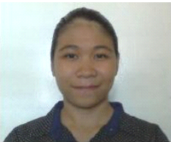

Maria
Abu Dhabi UAE
Maria.381305@2freemail.com

CAREER OBJECTIVE: Seeking for a position in your outstanding and vibant company that will fully utilize my knowledge and potentials for continuous career development.

WORK EXPERIENCE:

Department of Social Welfare and Development May 12 - July 15, 2015
Enumerator

SM Hypermarket Oct. 10 - Jan. 8 2016
Cashier

Saint Joseph High School of Laoag Inc. Jan. 11 - Apr. 1, 2017
Computer Teacher

Alorica Inc. May 30 2017 - Jan. 21, 2018
Customer Service Representative

EDUCATIONAL BACKGROUND:

Data Center College of the Philippines 2011 - 2015

Saint Nicholas Academy 2006 - 20010

Vintar Central Elementary School 2000 - 2006

SKILL
- Oriented in Microsoft Office applications
- Basic Computer Hardware and Software troubleshooting
- Customer Service oriented
- Excellent teamwork skills and independent working skills
- Excellent time management

PERSONAL DATA:
Date of birth: Nov. 1 1993
Place of birth: Vintar, Ilocos Norte, Philippines
Sex: Female
Civil Status: Single
Citizenship: Filipino
Height: 5’1”
Weight: 48 kg.
Religion: Roman Catholic

