Ahmed
Ahmed.381310@2freemail.com

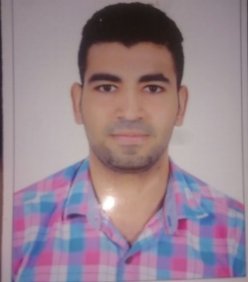
Objective

Seeking a position at leading company where I can make a positive impact by improving office efficiency, utilizing my exceptional time management skills, and contribute to organization’s long term goals.
Work Experience

Fitness Yard gym 2015 – 2016
Working as Fitness trainer

- Increase the fitness level of my customers
- development of physical fitness, speed, strength and flexibility
- Improve the efficiency of the heart and internal organs
- make diet plan for client
Work Experience

Snap Fitness gym 2016 - 2017
Working as personal trainer

1.Provide the client to achieve his goal by advising him and following up his Wight
2.transferring the client life style to be more healthy
3. make diet plan for client
Work Experience
Spot gym 2017-2018

- Working as professional trainer
- Provide the client to achieve his goal by advising him and following up his Wight
- transferring the client life style to be more healthy
- make diet plan for client

Education

faculty of physical education zagazig university 2013 - 2016
- Specialist in fitness
- studied sports games
Courses
- Cft (certified fitness trainer) ISSA
- Pt (personal trainer)
- Cpr
Skills

Personal skills:
- Professional, patient, cooperative and reliable.
- Analytical and eager to learn.
- Excellent communication skills.
- Able to work under pressure with excellent time management skills.

Languages:
- Arabic as a Native language.
- Good command of written and spoken English.
Computer Skills:
- Excellent command of all Office products.
Personal Information

Date of Birth : 01/10/1994
Marital status : Single Religion : Muslim Nationality: Egyptian
Visa: Visit
Expire Date :22 /7/2018

