Resume

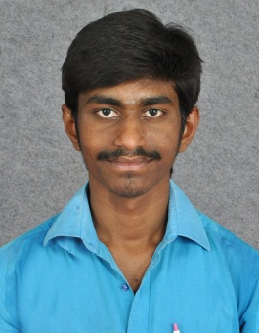
Ananth
e-mail: anath.381334@2freemail.com

Career Objective

To work with an organization where, is a scope for self-improvement and knowledge enhancement which will provide an opportunities to exhibit the best of my ability and contribute towards organizational development.

Skills & Abilities

- Knowledge in hydrostatic testing of Trunnion Mounted Ball Valves.
- Knowledge in understanding the requirements of GAD, Testing Procedure & Customer Specifications.
- Knowledge in international standards / specifications like API6D, ASME B16.34
- Knowledge about 5S practices.
- Knowledge in verifying the drawing requirements.
- Knowledge in 7 QC tools.

Education

- B.E mechanical engineering with 66.30%, (2009-2013). Saraswathi Velu College of engineering, Vellore.
- HSC with 76.66%, (2007- 2009)
Government higher secondary school, Ponparappi
- SSLC with 65.80%, (2007)
Government high school, Marudur.

Work Experience
1. I am working Exide industries limited in technician at Chennai (September 2013 to august 2014).
2. September 2014 to October 2017. | L&T Valves Limited, Kanchipuram.
 | Deputy Supervisor, Quality Control
Responsibilities:
- Shift In charge
- Achieving the daily targets
- Monitoring the testing activities
- Giving work instructions to the testers
- TPI offering

CAPABILITIES:

- Capable to do hydro testing Valves.
- Capable to understand the testing procedures and understand the testing requirements.
- Capable to handle Third Party Inspectors.
- Capable to prepare valve internal test reports.
- Capable to adapt to the new function or roll.

3. I am worked Gestamp Automotive Private Limited in Quality Control (November 2017 to still working here) at Sriperumbutur.

FIELD OF INTEREST:

- Quality control
- Manufacturing
- Valve testing

STRENGTH:
Adaptability, Optimistic Oriented, and Sustainability

LANGUAGES KNOWN:
- Tamil, English (Read, Write & Speak)

PERSONAL PROFILE:

Name: Ananth
Gender: Male Date of birth: 20.07.1992
Nationality: Indian
E-mail ID: ananth.381334@2freemail.com

