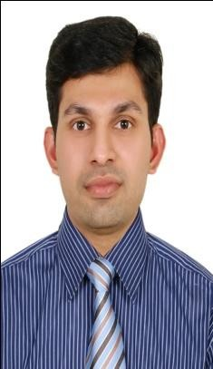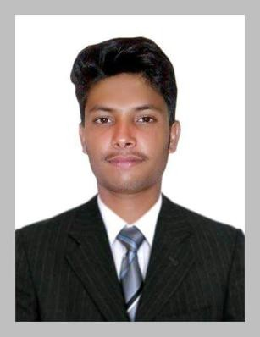
FROBLE

Email: froble.381336@2freemail.com

Personal Details:

Hobbies & Interests
- Playing Games
- Listening music
- Sports
- Martial Arts
- Traveling
- Creativity
- Hanging out with friends
- Racing
- Cricket
- Movies
- Surfing On Internet
Languages Known

- English (Fluent)
- Hindi (Fluent)
- Punjabi (Fluent)
- Urdu (Fluent)
CAREER OBJECTIVE
To work in a healthy, innovative and challenging environment e xtracting the best out of me, To put my abilities and learning skills to best use and make my effective contribution to an organization for a bright and rewarding career.
EDUCATION

Academic Qualifications:

- Passed Secondary School Education From Army Public School And College Ordnance Road, Rawalpindi,
Pakistan

Computer Skills:

MS OFFICE (Excel, Word, PowerPoint, Outlook) Internet, Antivirus, Photoshop, Movie-maker,
Fast Typing speed, etc…

Date of Birth | : | 21st March1997  Cancellation
Visa status | :
Nationality | : | Pakistani
Marital Status | : | Single
Religion | : | Christian

PARTICULAR TRAINING:-

- Department of Protective System Training [DPS] Dubai Police General HQ. My License is Valid Till 12-12-2019
- SIRA Card # 273104
STRENTH’S

- Interpersonal communication Skills.
- Self Motivating personality.
- Ability to work under-pressure.
- Planning & organizing and Decision making skills.
- Believe in team work.
- Positive Approach & Broad-minded.
- Quick Learner
- Has the ability to do work 18 hrs in a Day.
- Do every work with full confidence and passion.
- Ability to manage several assignments simultaneously.

PROFESSIONAL EXPERIENCE :-10th March 2018 to 1st June

- Currently Worked as a Security Officer with Emrill LLC, Dubai UAE
WORKING PROJECT
- NSHAMA Town Square Dubai
JOB RESPONSIBILITIES:-
- Taking and hand overing the duty with full responsibility.
- Patrolling of community and master community.
- Attending the complaints of residents.
- Handling of police and CID.
- Briefing of junior’s regarding duty post and community roles.
- Handling Lost & Found and informing to Senior.
NOTE:- The reason of resignation is contract finished

PROFESSIONAL EXPERIENCE:- November 2016 To July 2017
- Worked as a Reception Security Officer with CONCORDIA DMCC – Dubai UAE

WORKING PROJECT:-
- ICON- 2 Towers, Cluster-L, JUMEIRAH LAKES TOWER DUBAI UAE. ( Receptionist )

JOB RESPONSIBILITIES:-

- Ability to provide effective and efficient services to the client. Ability to analyze the data, resolve any problems and complete the work on deadline.
- Deal with all enquiries in a professional and courteous manner, in person, on the telephone or via E-mail.
- Maintain and update files, databases and records Familiarity with standard office administrative procedures.
- Demonstrated proficiencies in telephone and front-desk reception within a high-volume environment.
- Access control functions for an organization by verifying employee identification, issuing visitor passes, and observing and reporting any unusual or suspicious persons or activities.
- Ensuring safety and security of all staffs, guest, and customer. Responsible for to operate, monitor, and giving priorities to all security system, including CCTV Cameras, within the control centre in professional and efficient manner.
- Fire-panel operating/ Alarm System. Coordinating with maintenance staff and Assistance Of management.
- All Security Record (Lost & found, First Aid incident, Daily/Monthly Patrolling report, Daily/Monthly Security report, DEWA, PDC, BBQ, Moving in/out details, Emergency Lift telephone & Intercom Handling etc.

PROFESSIONAL EXPERIENCE:- April 2015 to July 2016
- Worked as a Customer Care Representative In Ascend Communication (Multinational Telecommunication Company) in Pakistan.

JOB RESPONSIBILITIES:-

- Enter data via computer, pertaining to the services provided by unit. Update database information to reflect most current source information.
- Proofread & verify data entered. Ensure accuracy of all information entered and presentation method.
- Assist with routine office duties such as typing, filing, and record maintenance. As workload permit’s, serve as back-up for other clerical position in unit.
- Retrieve information in the right format at the right time. Make necessary changes or correction.

Technical Knowledge: -

  - Window- Split AC Install, Maintenance and Repair from Fauji Foundation Technical Training Center.
  - Electrician Diploma from Fauji Foundation Technical Training Center.
  - Assembling of PC’s
  - Installation & Troubleshooting of Software’s & Hardware devices.
  - Installation & Troubleshooting of Operating system.
  - Basic Knowledge of Electrician and AC.

Achievements

- Won many Awards in Cricket & other Games in schools.

- Best Computer & Data operator in my Office.

- Also got prizes in drawing.

