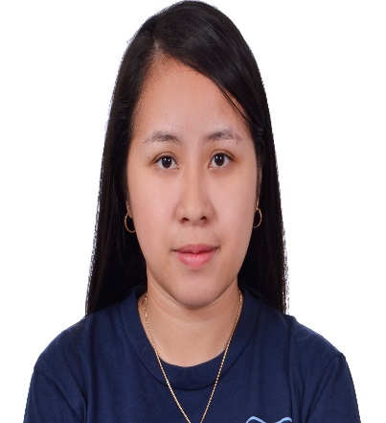
Tiffany
E-Mail Address: tiffany.381341@2freemail.com

I am focused, self-motivated, willing to learn new ideas and willing to accept challenges. I am detailed oriented and can finish work accurately in the most efficient way. I value the importance of honesty, sincerity and hard work. I can work on shifting hours and in minimum supervision. I am well versed in Microsoft Office Packages (Word, Excel and Outlook).

Work Experience:

Receptionist
October 2016 – May - 2018
Jumeirah, Umm Sequim 2, Dubai U.A.E.
- Greet clients as soon as they arrive and connect them with the appropriate party
- Answer the phone in a timely manner and direct calls to the correct offices
- Create and manage both digital and hardcopy filing systems for all partners
- Make travel arrangements and schedule meetings based on all partners’ itineraries
- Deal with bookings by phone, e-mail, letter, fax or face-to-face
- Complete procedures when Guests arrive and leave
- Prepare bills and take payments
- Take and pass on messages to Guests
- Deal with special requests from Guests
- Answer questions about what the hotel offers and the surrounding area
- Deal with complaints or problems

Office Secretary
November 2014– June 2015
Philippine Post Office
1018, 2nd Street, corner Bonifacio Drive, Port Area, Manila, 1000 Metro Manila, Philippines
- Word processing.
- Audio and copy typing.
- Letter writing.
- Dealing with telephone and email enquiries.
- Creating and maintaining filing system.
- Scheduling and attending meetings, creating agendas and taking minutes - shorthand may be required.
- Keeping diaries and arranging appointments.
- Organizing travel for staff.

Data Encoder
April 2014 – October 2014
Ecomoda Marketing
Puritan Philippines, Inc. (PPI) Building, 355 EDSA cor, General Tirona Rd, Bagong Barrio West, Caloocan, Metro Manila (Philippines)
- Maintaining hard copies of patient forms, receipts, applications and other types of documents.
- They also do transcription, scanning of documents and maintaining backups of data entered.
- They are responsible for compiling, sorting and verifying the accuracy of data before it is entered
Includes fast typing and data entry speed, as well as being highly detail oriented, accurate, and able to identify errors and good at verbal and written communication.

Administrative Assistant
June 2013 – April 2014
Philippine Statistic Authority
Diosdado Macapagal Government Center, Barangay Maimpis, City of San Fernando, Pampanga (Philippines)
- Administrative assistants perform clerical duties in nearly every industry.
- Some administrative assistants, like those in the legal industry, may be more specialized than others.
- Most administrative assistant duties revolve around managing and distributing information within an office.
- This generally includes answering phones, taking memos, and maintaining files.
- Administrative assistants may also be in charge of sending and receiving correspondence, as well as greeting clients and customers.

Language Spoken:
Filipino: Fluent
English: Fluent

Personal Background:

Date of Birth : June 24, 1992
Place of Birth : Caloocan City
Age : 25
Civil status : Married
Gender : Female
Citizenship : Filipino
Height : 5’0”

Educational Background:

Tertiary
ACLC College of Apalit
2009-2013
Course:Bachelor in Science in Computer Science
Major in Multi-media

Secondary
Saint Vincent’s Academy
2005-2009

