Rayan

Customer Services Professional

Customer Services Representative

Executive Sales Assistance
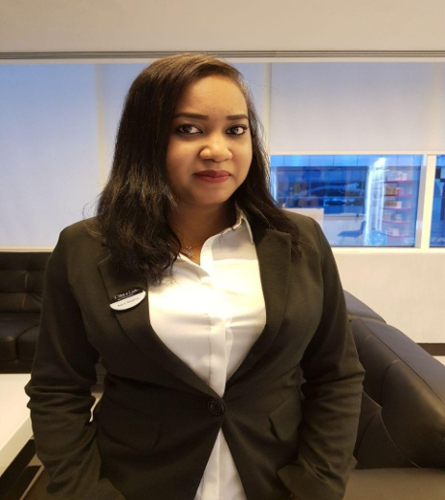

Profile Overview:

DOB: 23-09-1988

M Status: Single

Nationality: Sudanese

Religion : Muslim

Current location : Dubai

Visa Status: Visit Visa (until 2nd May)

Contact:

Email: ​rayan.381352@2freemail.com

Dubai, UAE

Personality:

I am enthusiastic person, ambitious and career minded, with a willingness to learn and adapt. I am a responsible, reliable player with professionalism and commitment that drivers goal achievement. My abilities to develop practical and scientific.

I protect the privacy and security of our guest, my fellow employees and the company’s confidential information and assets. And i’m proud of my professional appearance, language and behaviour.

Language : English & Arabic fluant

My Education Journey:

University Specialization Graduation Year Secondary School Primary School

: Sudan University of Science and Technology.

: Diploma of Petroleum Engineering (3years).

: (2011)-(2012).

: Omdurman (Omdurman West Secondary School).

: Abrouf primary School.

My Work Experience :

2014-2017: Head Receptionist- Receptionist Supervisor- Retail seller at The Ritz-Carlton Hotel Abu Dhabi, Grand Canal.

2011-2014: Health Club Receptionist- Handling telephone Emails inquiries -Data entry of all gym and spa memberships -Submit the daily sales reports -Team leader.
At Corinthia Hotel khartoum, Sudan

2010 : Sales coordinator, sales representative at Al Ealania Newspaper (Khartoum, Sudan).

Professional work and daily tasks:

- Greeting and welcoming all the customer with warm approach.

- Handling all customers inquiries and complaints through emails as well as phone calls.

- Performing activation Schedules .

- Retails selling and promoting the services & products to the customer, and targeting local market.
- Payroll, vacation plan and daily shift schedule for the staff.

- Daily sales duties, sales reports.

- Monthly inventory and cost control.

- Monthly P&L analysis with Finance

- Monthly staff incentive and commission reports.

- Marketing Plan

- Handling administrative requests & queries from senior managers.

- Organising and scheduling appointments with admin software.

- Planning meeting and taking details minutes.

- Write and distribute email, correspondence memos, letters, faxes and forms.

Awards & appreciation certificate:

- Employee of the Month, front of the house at Corinthia Hotel Khartoum in 2012

- Best Retail seller of the month september at The Ritz-Carlton Hotel in 2014.

- Lateral Services appreciation certificate at The Ritz-Carlton Hotel may 2015.

- Part of Awards winning team, of Best Spa person & Best Spa Design at The Ritz-Carlton Hotel in 2016.

- 5 Star Employee of the second quarter 2015, at The Ritz-Carlton Hotel in 2015.

Training and Skills:

- Computer knowledge of all MS office programs, practicing of 8 years.

- Community Based Health First Aid 2012.

- Cross Training in IT Department 2012- 2013.

- ESPA Philosophy and Products Knowledge 2014.

- Marriott International Security and privacy Training (ISPT) 2016.

- Supervisor Skills Development Training (2 days) 2017.

- Learning Coach Certification (Train the Trainer) 2017.

- Time Management (Online Training).

- Communication Skills Training.

- Optimizing your work/Life balance: taking control of your stress (online).

- Your Role in Preventing Human Trafficking (online).

- Spasoft system, Birch street system, operah.

