SREEJITH  E-Mail: sreejith.381361@2freemail.com | 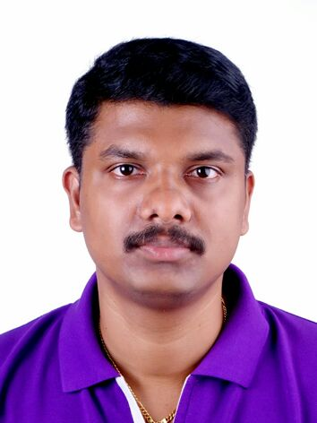

Professional Experience

WE TECH ENGINEERS, NAVI MUMBAI
June 2017 – May 2018

- Detailing of 2D/ Isometric drawings.
- Checking/Creating General Arrangement and fabrication detail drawings.
- Detailing of platform & ladder.
- Detailing the stair case and hand rails.
- Preparing Bill of Material for overall drawings.

TOPSIDES ENGINEERING CONSULTANCY FZE, AJMAN (UAE) October 2014 – April 2017

- EVERSENDAI OFFSHORE RMC FZE Dubai, UAE

1. New Built Project of Self Propelled Jack-ups ARYAN & ARJUN Project
- Experience in Auto CAD 2D And Aveva Marine Drafting.
- Prepared Detail Design Drawing for Hull Scantling.
- Preparing of Detail drawing for spud can & leg well.
- Preparing of bending template and Weld Map Drawing for the project.
- Aveva Marine Drafting to Produce Fabrication Detail Drawing

- CHALMERS MARINE ENGINEERING , DIP-2 , DUBAI

1. FPSO CATCHER MARINE Project

- Checking/Creating General Arrangement and fabrication detail drawings.
- Detailing of EIT Equipment foundation drawings, grating drawings, Fire House Reel Box drawings, Laundry Equipments, Roller shutters, and HVAC Fan Foundation Drawings.
- Detailing for Piping Box-UP drawings, Instrumentation & PDT Tubing supports and GA.
- Detailing of 2D/ Isometric drawing’s
- Detailing of surface light external light GA & Support.

2. BORWIN 3- HVDC CONVERTER PLATFORM Project

- Preparing fabrication detail Support drawings for service supports.
- Preparing MTO for overall drawings
- Model Review by Navisworks

SIEGHART ENGINEERS AND STRUCTURAL DETAILERS, New Delhi, India June 2010 – August 2014

- Experience in Auto CAD 2D, Solid works And TEKLA (Basic)
- Prepared fabrication detail drawings for duct, chute, silo, support structure, etc.
- Prepared layout drawings of Storage Tank for Indian Oil Corporation.
- Detailing of 2D/ Isometric drawing.
- Detailing the stair case and hand rails
- Preparing the Bill of Material.
- Prepared GA, & fabrication drawing for handrail, staircase, platform, ladder, etc.

Main Projects Handled
- BORWIN 3- HVDC Converter Platform
- FPSO CATCHER Marine
- ARYAN&ARJUN Self Propelled Jack-ups
- Prepared Detail Design Drawing for Hull Scantling
- Storage Tank - development & detailing for Indian Oil Corporation.(Solid Work & Auto CAD)
- US Duct Work - Furnace Improvements Texas
- ACC, ULTRA TECH, JAMUAL, cement industry works
- Editing of Structural drawings for L&T, Technip, Samsung etc

Academic Credentials

2010 Diploma in Mechanical CADD from CADD Centre Thiruvalla (Auto CAD & Pro/E)

2009 Diploma in Engineering (Mechanical) ARUNACHAL University from West Coast College OF engineering Kayamkulam
.
 Pre-Degree (+2) V.H.S.S Kallissery, Kerala

2005 SSLC (10th) St.Thomas HSS, Thirumoolapuram, Kerala

Computer Skills

- AutoCAD 2D & 3D (all versions)
- TEKLA (Basic)
- Solid Works, Pro/E
- Marine Drafting (AVEVA) & Navisworks
- MS Office (Word, Excel & Power Point)
- Internet Services and Basic Computer Operations

Personnel Details

Date of Birth : 7th February 1990
Linguistic Abilities :     English, Hindi, Malayalam and Tamil
Marital Status      Married
Nationality :     Indian
Passport expires date:    22/07/2020

INTERESTING WORK AREAS

- Design/Drafting
- Supervision
DECLARATION
I do here by confirm that the information given in this form is true to do the best of my knowledge and belief.

SREEJITH

