Curriculum vitae 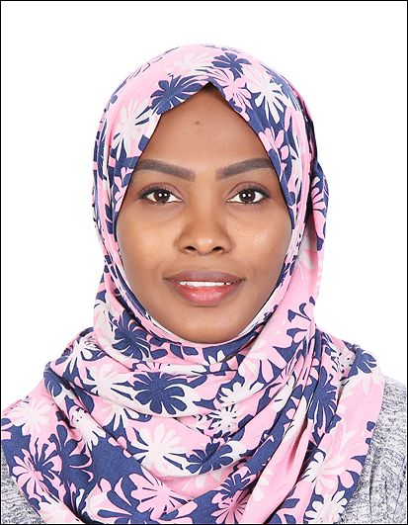

Name: Doaa
Email: doaa.381381@2freemail.com

Objective: : I am seeking a competitive and challenging environment where I can serve your organization and establish an enjoyable career for myself.
Work Experience:
April-2016 till april-2018: I have been working as architectural engineering at Mustafa Musa Mustafa Enterprises for contracting:
- Assistant site engineer in concrete structure
- Assistant site engineer in finishing works
- Designer in technical office
- as well (As built) of electric works
Educational Qualification:
- Diploma in Architecture , Sudan University of Science & Technology (3 years )
Additional Training and courses:
- AutoCAD Drawing Program.
- Revit Drawing Program.
- Quantity Calculation Using Plan Swift.
- 3D Studio max & Vray & Photoshop.
- Architectural plans rendering with Photoshop.

Languages:
- Arabic (Mother tongue)
- English.
Skills:
- Good communication skills.
- MS Office : (Word, Excel, Power Point)
- Email & Internet: Excellent knowledge in internet usage.
Personal Information:
- D.O.B: 15 April 1992
- Sex: Female
- Marital Status: single
- Nationality: Sudan
- Visa Status: Visit visa

I hereby declare that all the above furnished details are true to the best of my knowledge.

