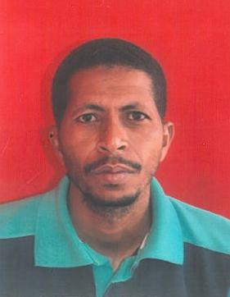
CURICULUM VITEA

ALI

Email Id: ali.381394@2freemail.com

Dubai, United Arab Emirates

Objective:
I look forward to a career where I will have enough challenges to encounter, prospects to grow and chances to prove myself to be a value addition by contributing to the development of the organization. At the same time, I want my career to be meaningful, rewarding and satisfying.
Personal Information:
Nationality : Sudan
Date of Birth : 01/01/1981
Sex : Male
Marital Status : Married
Visa : Visit
Qualification:
B.S.C (Honors),Food Engineering Technology, Faculty Of Engineering And Technology,Gezira University ,2008
Experience:
June – 2010-May 2012 Africa City Of Technology As A Food Technologist,
2013- Up To Date -Started Small Food Packaging Business
Training Course:
March 2018: Lead Implementer And Certified Food Safty Consultant For FSMS ISO /DIS 22000:2018
Languages Known:
English and Arabic
Personal Skills:

- Good Communication
- Dedication Towards Work
- Good Team Spirit And Hard Working Nature
Declaration:
I hereby declare that all the details mentioned above are true and benefited to the best of my knowledge and belief.

ALI

