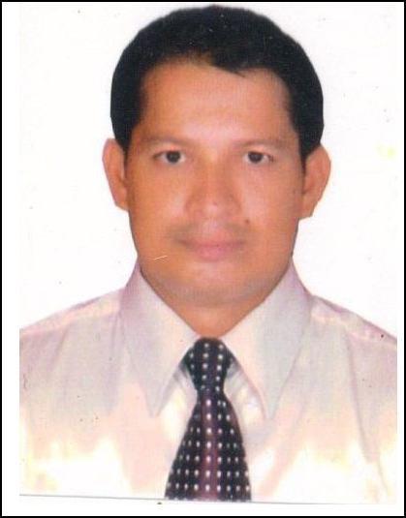
CURRICULUM VITAE

SUSHIL KUMAR,

Email: sushil.381416@2freemail.com

OBEJECTIVE

Contribute to a dynamic growing organization where my strong analytical, inter personal skill and hard work will have a significant impact. The optimal position will provide professional growth and opportunities to contribute.

WORK EXPERIENCE

- Captain at OCACTI MEXICAN HOUSE & COCKTAIL BAR, PIER 7, DUBAI MARINA from Feb 2015 to till now. (3 years)

WORK PROFILE

Taking Order and serving to the guest.

Help in boosting the restaurant revenue fig.
Monitor & Control the work of subordinates.
Suggestion to seniors for sales promotions.

- Senior Waiter at PEPSI BLUO, AMBIANCE MALL,NEW DELHI, INDIA from March 2011 to 31st Dec 2014. (3 years and 10 month)

WORK PROFILE

Taking Order and serving to the guest.
Help in boosting the restaurant revenue fig.

- Waiter at Kwality Groups Of Restaurants, New Delhi , INDIA from July 2008 to Feb 2011.(2 years and 8 month)

WORK PROFILE

Taking Order and serving to the guest.
Help in boosting the restaurant revenue fig.

INDUSTRY TRAINING

The Peerless Inn, Kolkata

Industrial Training for a period of six months from 15th January, 2007 to 18th June, 2007 in the following areas:

- Sales & Marketing

- Accommodations Operations
- Food and Beverage Service.
- Front Office.

Achievements

As a trainee in the sales department “The Peerless Inn, Kolkata ” performed the following :

- Helped in boosting the hotel sales to appreciable figures.

- Added new names to the clientele

- Helped in Increasing the ARR (Average Room Revenue) during off seasons

- Appreciated on numerous occasions for the effort put in.

EDUCATIONAL QUALIFICATIONS

Course | Year of | Name of University/Institution
 | passing
Bachlor Degree in hotel | Feb 2008 | BIT , Mesra Ranchi, India
management & Catering
Technology
MBA(Perusing) | 2017 batch | Symbiosis

LANGUAGE KNOWN
English, Hindi
PERSONAL DETAILS
Name |  |  | SUSHIL
Date of Birth |  |  | 15th July 1983
Gender |  |  | Male
Marital Status |  |  | Married
DECLARATION

I hereby declare that the above furnished information are true and fair to the best of my knowledge & belief.

