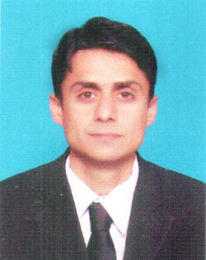
Resume

Nauman
Nauman.381427@2freemail.com
Post applied for: Security Guard

Objective
My objective is to achieve excellent in a dynamic friendly organization. I enjoy working as part of an efficient team in a friendly environment. I am capable of working on my own imitative and possess excellent to communications skill and I am able to work under pressure to meet deadlines. I always work hard and efficiently to achieve my goal.

Personal profile
Date of Birth | 23-03-1985
Marital Status | Married
Religion | Islam
Nationality | Pakistani
Gender | Male
Visa Status | Visit visa

Examination Session Board/ University
S.S.C 2001 BISE Peshawar
F.A 2007 BISE Peshawar

Verify by I.B.C.C & U.A.E embassy
Experience
- 2 years experience as a security guard in star security services abu dhabi
Exam pass P.S . B.S in 2007.
- 2 years experience in security guard emrill L.L.C Dubi exam pass D.P.S in 2011.
- I have DPS Certificate

Languages
Arabic Can Read, Write & Speak
English Can Read, Write & Speak
Urdu Can Read, Write & Speak
Pushto Can Read, Write & Speak

